AI and breaking down brick walls

In early December 2024, Family Search uploaded a test site which included links to images of handwritten manuscripts held at the Registry of Deeds coupled with AI generated transcriptions. Even with all the garbage which is found in work done by non-humans, this is a game-changer.

Deeds research when I started in 2003 - Climbing up ladders.
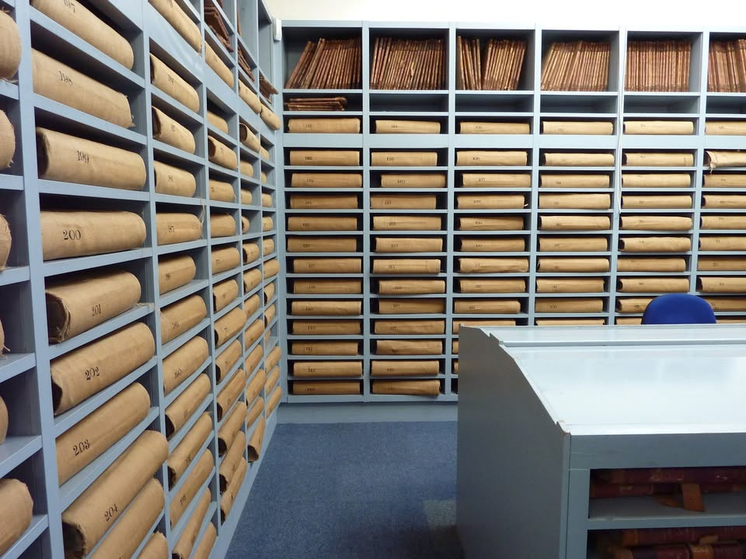

Because I have heard from some folk that they had trouble finding what they sought, I decided to share my approach:

Start with: Ireland, Properties, from 1298 to 1975 and then set some parameters. Start your search wide and then narrow it down. In this case, under “place” I had initially included Armagh – but got no hits. In the end, I ended up with only two parameters, which resulted in 104 hits:

- Keywords: Armagh
- Name: “John Oliver”
- Place: NOTE: I left it blank.
- Year range NOTE: I left it blank. It never seems to make a difference.

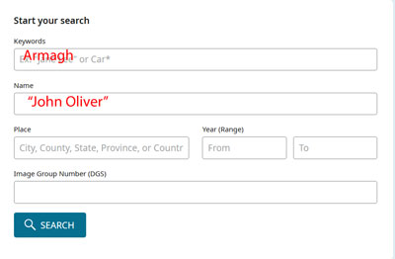

Many of the 104 hits were for leases which I knew about, so I clicked on a link to one that I hadn’t recognized.: A 1867 entry for Landed Estates Court to Boyle, which included John, Mary and Elizabeth OLIVER of Ballinahonebeg, people I had already encountered in my research. I still knew little about what had happened to all the land leases of these OLIVERs.

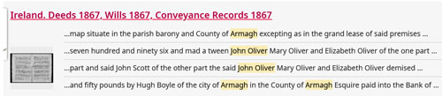

In the link above, we can see that this entry was recorded in 1867, and when we click and link to the image of the document, we can see that it was # 290. On the sidebar to the right of the document is the AI transcription, which I then cut and paste, and save in a WORD doc. It takes a bit of fiddling to find where to start and where to finish, but it isn’t rocket science.

To take the next steps, we still need the Book #. This is key. The thumbnail icon – outlined in red in the screen grab beneath – can be used to scroll back until you find the book number.

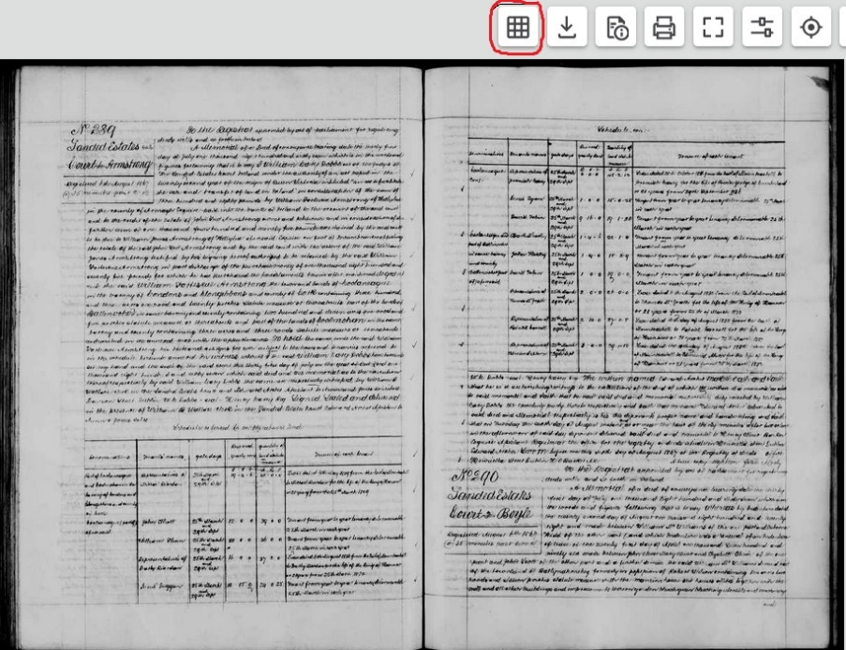

Once done, we can see that the full reference is: ROD: 1867-24-290. For reasons that perplex me, the image numbers on the AI page are not always the same as those in the microfilm versions found online at the main Family Search page. This is where Nick Reddan’s Registry of Deeds Index Project is a great help. Type in 186724 at the bottom left and you will get to the correct book number. Then you can navigate your way to the exact document. NOTE If the year is 1825 or later and if the volume number is less than 10, say volume #5, then you need to add a zero in your search, for example: “186705”.

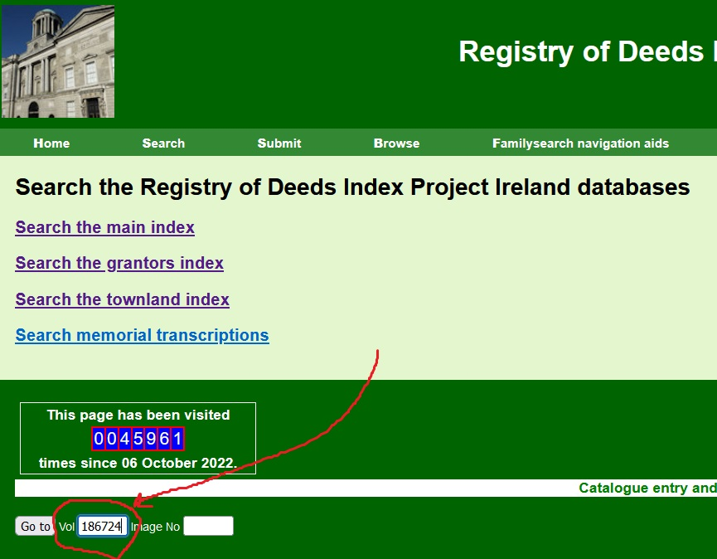

Meeting Nick Reddan in Dublin. 2011.
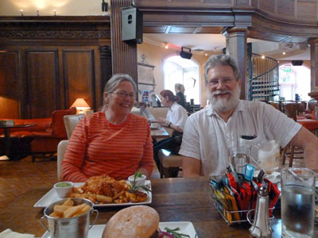

My method is then to create a WORD doc for each ROD and include both the AI version, as well as my edited version. The AI is beneath – no need to read it - so you can compare it with my edit in case you wish to. There are not too many hiccups in this one, but I have highlighted them to give a sense of what it ends up looking like. NOTE; When there is text in the column to the left of the page, it often gets merged with the main text. Gobbledygook. Also, AI often gets names wrong. For example, “Osburn Ridd” is actually “Osborne KIDD”. Unfortunately, scrambled words or names can skew searches. In another search I did, “Dame Street” was often rendered as “Dane Street” and consequently did not show up until I searched for Dane Street.

Image 621
A Memorial of a deed of conveyance bearing date the thirty first day of July one thousand Eight hundred and sixty seven which is in to Boyle the words and figures following that is to say whereas by Indenture dated the twenty second day of August one thousand eight hundred and twenty Dated August 6th 1867 eight and made between William McWilliams of the one part and Osborne Ridd of the other part and which Indenture was a renewal of an Indenture ┃ minutes past two of of lease of the twenty first day of April one thousand Seven hundred and ninety six made between John Oliver Mary Oliver and Elizabeth Oliver of the one part and John Scott of the other part and a further demise the said William McWilliams demised part of the townland of Ballynahonebeg formerly in possession of Robert Wilson containing ten acres two roods and sixteen perches statute measure with the mansion house out houses office together with the well and all other buildings and improvements thereon garden beach green bleaching utensils and machinery and

and all water and water courses mill dams wer tail race and waste water course and also the small part or piece of ground on the other side of the river opposite the said bleach green between the river and the road to Kennedier containing three rods and twenty seven perches also the field below the bridge known by the name of the Home or Rand lying between the high road and the River containing three acres and seventeen perches with liberty to repair the said wer mill dam and tail race & also that field containing two acres one rood and twenty six perches situate between other lands of said Y William McWilliams and the lot marked No 1 on map therein referred to and also that field containing three acres one rood and twenty four perches and the field containing two acres two roods and thirty two perches also marked on said map situate in the parish barony and County of Armagh excepting ┃ as in the grand lease of said premises held by John Jackson was excepted and reserved unto the said Osborne Ridd for the term of nineteen years computed from the first day of November one thousand eight hundred and twenty seven and for such further terms of years as should be added pursuant to the covenant for renewal therein after contained at the yearly rent of eighty two pounds payable half yearly on the first day of May and first day of November in each year and said Indenture named a covenant on the part of said William McWilliams for the renewal tories quities of said lease on the payment of proportionable part of the fine and expenses of renewal and whereas the last renewal of said leases was made by an Indenture which bears date the eighteenth day of November one thousand eight hundred and sixty five and is made between George McWilliams of the one part and said Osborne Ridd of the other part and is for the term of eleven years from the first day of November one thousand eight hundred and sixty five and whereas by one other Indenture bearing date the twenty first day of April one thousand seven hundred and ninety six and mad a tween John Oliver Mary Oliver and Elizabeth Oliver of the one part and said John Scott of the other part the said John Oliver Mary Oliver and Elizabeth Oliver demised that small Island at foot of the west of Ballynahoney in the river Callan between the lands of Ballymahon beg and the lands of Kennedies and containing one rood as described on the map of Ballynahone beg therein referred to situate in the parish and County of Armaght reserving liberty to the Vicars three of Arnough to raise and and gravel for their use and take it through said lands of Kennedies and are take liberty for said John Oliver Mary Oliver and Elizabeth Oliver their executors administrators and assigns to raise and remove the same unto the said John Scott his Executors administrators and assigns for the term of nineteen years from the first day of November one thousand Seven hundred and ninety five and for such further term of years as should be added pursuant to the covenant for renewal therein after contamed at the yearly rent of one shilling payable hold yearly and said Indenture contained a covenant for renewal toter quotes on payment of one pepper comon each renewal Now I William Cary Dobbs one of the Judges of the Landed Estates Court Ireland under the authority of and passed in the seventy second year of the reign of Queen Victoria intitled " an act to facilitate the sale and transfer of land in Ireland in consideration of the sum of ┃ six hundred and fifty pounds by Hugh Boyle of the city of Armagh in the County of Armagh Esquire paid into the Bank of Ireland to the account of the said court and to the credit of the Estate of Osborne Kidd owner and petitioner do grant unto the said Hugh Boyle the said lands of Ballynahoney in the barony of Armagh and County of Armagh expressed to be demised by the herein recited Indentures do described in the annexed map ( except do in the said leases are excepted ) with the appurtenances To hold the same unto the said Hugh Boyle his executors administrators and assigns as to the premises demised by the first recited lease for the unexpired residue of the term of eleven years created by the said recited Indenture of renewal and for such other terms as may be added thereto pursuant to the covenant for renewal therein contained and as to the premises demised by the second recited Indenture for such other terms as may be added thereto pursuant to the covenant for renewal therein contained subject to the payment of the respective unto respectively reserved by the said respective leases ┃ and to the performance of the covenants and agreements on the leper 's part therein respectively contained and subject to the tenancy from year to year of said premises containing three acres statute measure of Robert McCrea at the yearly rent of thirty two pounds payable half yearly on the first day of May and first day of November in each year and the year of whose tenancy is determinable on the first day of May in each year and subject also to all rights may now exist in respect of the water power of the river ┃ In witness whereof I the said William Cary Dobbs have hereunto set my hand and the seal of the said Court NO Law Cow Regist 20 Court this thirty first day of July in the year of our Lord one thousand eight hundred and sixty seven which said deed and this memorial as to the due execution thereof respectively by the said William Mary Dobbs the same are respectively witnessed by William B Wallace Serk in the Landed Estates Court and Edward Archer of Pleasant View Dublin Gentleman W W Dobbs - seal - Henry Carey Reg Signed sealed and delivered in the presence of William B Wallace Clerk in the Landed Estates Court Edward Archer Pleasant View Dublin Gentleman the above named Edward Archer maketh Oath and Saith that he is a subscribing witness to the deed of which the above writing is a memorial as also to said memorial and saith that he saw said deed and memorial respectively duly executed by William Cary Dobbs the execution party thereto respectively and that the name Edward Archer subscribed as a witness to the execution of said deed and memorial respectively is his this deponents proper name and handwriting and saith that on Tuesday the sixth day of August one thousand eight hundred and sixty seven and at or near the hour of thirty five minutes after two o'clock in the afternoon of said day deponent delivered said deed and memorial to Henry Oliver Barker Esquire Assistant Register at the office for the registry of deeds Henrietta Street Dublin Edward Archer Sworn before me this ┃ 6th day of August 1867 at the Registry of deeds office Henrietta Street Dublin H. Barker B ┃ 291 a true copy twenty foolen Arbly

My approach to editing the AI version is to:
- delete unneeded verbiage;
- for dates, acreages and money, use numbers (ie 1867; 4a 2r 5p; £32) instead of words (often easier to find in digital searches);
- put all surnames in UPPERCASE (easier to spot in a quick scan); and
- insert links to townlands using data at townlands.ie.

In this deed, a link in townlands.ie shows the boundaries of: Ballynahone Beg, Parish Lisnadil (Armagh portion), Barony Armagh. When the map is viewed together with the text, it clarifies why the water rights and access etc. mattered. It also helps me to understand why my g-g-g-grandmother Eliza JACKSON née OLIVER (1814-1903) blamed the KIDD family for the loss of the OLIVER lands, which she felt should have come to her and her children. NOTE: The Callan, mentioned in the deed, is the upper middle river.
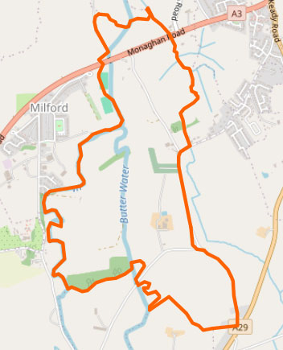

For further context, it also helps to refer to other compilations: SEE: Co, Armagh Memorials of Deeds in three parts: Part 1 (BK 1-329 - 1708-1779); Part 2 (Bk330 - 1779-1829); Later Deeds: 1830- NOTE: I will soon be updating such pages with my new AI enabled transcriptions.

Finally, here is what my edited version of the deed looks like (corrections always welcome):
A Memorial of a deed of conveyance 31 Jul 1867 whereas by Indenture 22 Aug 1820 made between William McWILLIAMS of the one part and Osborne KIDD of the other part and which Indenture was a renewal of an Indenture of lease 21 Apr 1796 BTW John OLIVER Mary OLIVER and Elizabeth OLIVER of the one part and John SCOTT of the other part and a further demise the said William McWILLIAMS demised part of the townland of Ballynahonebeg [Ballynahone Beg, Parish Lisnadil (Armagh portion), Barony Armagh] formerly in possession of Robert WILSON containing 10a 3r 16p statute measure with the Mansion house out houses office together with the well and all other buildings and improvements thereon garden beach green bleaching utensils and machinery and and all water and water courses mill dams weir tail race and waste water course and also the small part or piece of ground on the other side of the river opposite the said bleach green between the river and the road to Kennedys [[Kennedies, Parish Lisnadil (Armagh portion), Barony Armagh], containing3r 27p also the field below the bridge known by the name of the Home or Island lying between the high road and the River containing 3a 17p with liberty to repair the said weir mill dam and tail race & also that field containing 2a 1r 26p situate between other lands of said William McWILLIAMS and the lot marked No 1 on map therein referred to and also that field containing 3a 1r 24p and the field containing 2a 2r 32p also marked on said map situate in the Parish Barony and County Armagh excepting as in the grand lease of said premises held by John JACKSON was excepted and reserved unto the said Osborne KIDD for the term of 19 years computed from the 1 Nov 1827 and for such further terms of years as should be added pursuant to the covenant for renewal therein after contained at the yearly rent of £82 … said Indenture named a covenant on the part of said William McWILLIAMS for the renewal tories quities of said lease on the payment of proportionable part of the fine and expenses of renewal and whereas the last renewal of said leases was made by an Indenture 18 Nov 1865 BTW George McWILLIAMS of the one part and said Osborne KIDD of the other part and is for the term of 11 years from the 1 Nov 1865 and whereas by one other Indenture 21 Apr 1796 BTW John OLIVER Mary OLIVER and Elizabeth OLIVER of the one part and said John SCOTT of the other part the said John OLIVER Mary OLIVER and Elizabeth OLIVER demised that small Island at foot of the west of Ballynahonbeg [Ballynahone Beg, Parish Lisnadil (Armagh portion), Barony Armagh] in the river Callan between the lands of Ballymahon beg and the lands of Kennedies and containing one rood as described on the map of Ballynahone beg therein referred to situate in the parish and County of Armagh reserving liberty to the Vicars Choral of Armagh to raise sand and gravel for their use and take it through said lands of Kennedies and also take liberty for said John OLIVER Mary OLIVER and Elizabeth OLIVER their executors administrators and assigns to raise and remove the same unto the said John SCOTT his Executors administrators and assigns for the term of 19 years from the 1 Nov 1795 and for such further term of years as should be added pursuant to the covenant for renewal therein after contained at the yearly rent of 1s payable hold yearly and said Indenture contained a covenant for renewal toties quoties on payment of one pepper corn each renewal. William Cary DOBBS one of the Judges of the Landed Estates Court Ireland … in consideration of £650 fifty by Hugh BOYLE of the city of Armagh in the County of Armagh Esquire paid into the Bank of Ireland to the account of the said court and to the credit of the Estate of Osborne KIDD owner and petitioner do grant unto the said Hugh BOYLE the said lands of Ballynahonbeg in the Barony of Armagh and County Armagh expressed to be demised by the herein recited Indentures so described in the annexed map (except as in the said leases are excepted) with the appurtenances To hold the same unto the said Hugh BOYLE his executors administrators and assigns as to the premises demised by the first recited lease for the unexpired residue of the term of 11 years … and subject to the tenancy from year to year of said premises containing 3a statute measure of Robert McCREA at the yearly rent of £32 payable half yearly and subject also to all rights may now exist in respect of the water power of the river. WITNESS: William B WALLACE Clerk in the Landed Estates Court and Edward ARCHER of Pleasant View Dublin Gentleman W W DOBBS – [SEAL]
NOTE: Elizabeth OLIVER, Mary OLIVER and John OLIVER were all children of Joseph OLIVER (1727-1795) and Jane OATS (bt 1728-1786). Their ancestors were (allegedly, and likely) Huguenots who settled in Ireland shortly before or just after the revocation of the Edict of Nantes in 1685.

Before AI, my main tools were the grantor and townland indexes. This lease would not have been flagged as being connected to OLIVERs in either of them. An additional benefit is that the task of editing AI text is way less than having to type it all up from scratch. As I said at the start – this is a game changer. Thanks to all those who made it possible.

