Mrs. Elizabeth JACKSON née BUNTING

The devil is in the details. True, but those damned details can be devilishly hard to nail down. Especially when certain people, actions and perspectives have not been part of the shared narratives for hundreds of years. For me, this is why the opening sentence in the article in the May 22, 1795 edition of The Times (London, Greater London, England) matters: The late Parson Jackson, was twice married, and has left a wife to lament his unhappy end. Women appearing in the lead sentence? Rare. Even so, and typically, both wives are left unnamed.

A range of sources reveal that Parson Jackson’s 2nd wife was key to securing money to pay for the legal battles of Parson Jackson aka Rev. William JACKSON (1737-1795). After the Court had found him guilty of treason and collusion with the French as part of a United Irishmen plot to free Ireland from the yoke of English rule, he died of arsenic poisoning before sentencing concluded. Elizabeth may have secured the arsenic, likely at his request. The fear was that the State would seize their shared assets, unless he died before his sentence was pronounced.

This much was known, that Jackson took poison with the idea that the little means he possessed would be preserved to his wife and children, if the sentence of the law was not pronounced on him, and that the party who was privy to this act must have well known the nature of the poison, for the time of its operation was evidently calculated on correctly.
The United Irishmen: Their Lives and Times. Richard Robert Madden, The Shamrock edition, Newly Edited With Notes, Bibliography And Index By Vincent Fleming O’Reilly, The Catholic Publication Society 1916. p 186

The marriage documents for either of the two wives had long eluded researchers, but a few days ago, Laura McKenna, an author from Co. Cork (Words to Shape My Name), contacted me. Thanks to her eagle eyes, we finally have – indisputably – a record of the 2nd marriage of Rev. William Francis JACKSON to Elizabeth BUNTING. This removes one layer of her invisibility.

Marriage at Saint George The Martyr: Borough High Street, Southwark, England
Rev. William Jackson, Parish Fulham, Co. Middlesex, Widower and Elizabeth Bunting of this Parish spinster. married in this church by licence this Fifth Day of August in the year One Thousand seven Hundred and Ninety Two by me Thomas Wigrell Curate. This marriage was solemnized between Us: Wm. Francis Jackson; Elizabeth Bunting.
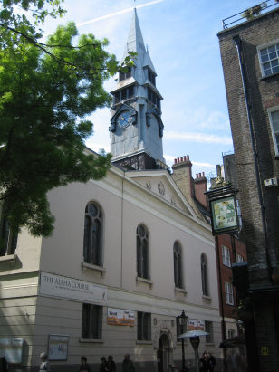
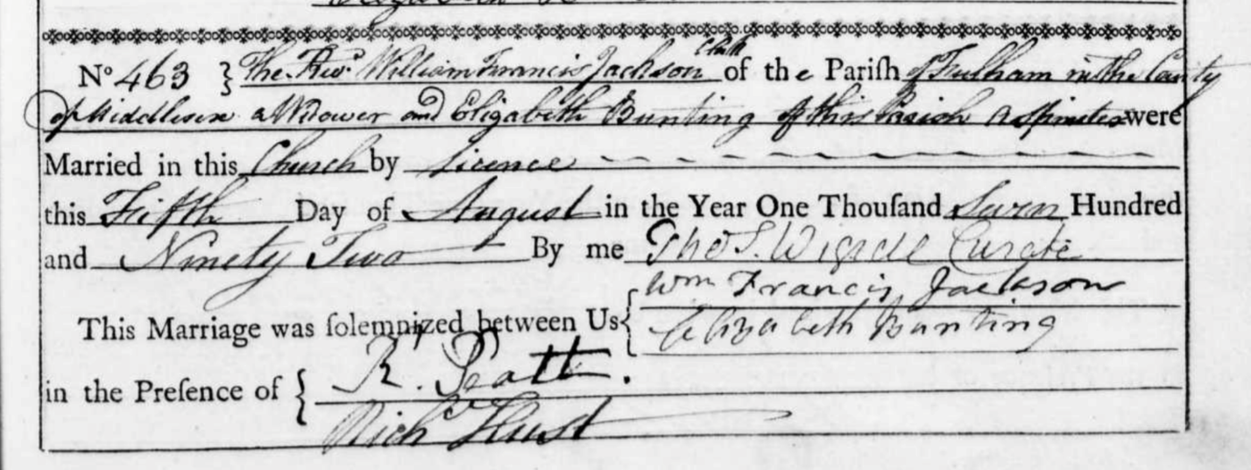

The signature in the marriage cert is a dead ringer for the signature on another document, signed in 1792, at the White Hotel in Paris. There can be no doubt that this is “our” Rev. William.

First page of the ‘Adresse des Anglais, des Ecossais et des Irlandais résidans et domiciliés à Paris’ to the Convention, presented on 25 November 1792. The address was part of a dialogue between the Société des Amis des Droits de l’Homme (SADH) and the French government about the possibility of an insurrection in Britain and/or Ireland in late 1792. Though the early Irish republicans did not get their wish, notably because of the astute policy of Pitt’s cabinet, their political activism between Dublin, Belfast, London and Paris shows that Irish republicanism grew alongside its French counterpart. (Archives Nationales, Pierrefitte-sur-Seine).
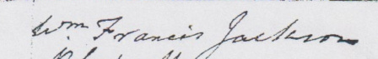

Sylvie Kleinman, a Dublin historian and author, was the first to alert me to this signature. More recently, Ruari Nolan also included it in a substack piece: Address of the English, Scotch, and Irish resident and domiciled in Paris (1792). His piece included a link to the source document by Mathieu Ferradou: ‘Un festin patriotique’ at White’s Hotel, 18 November 1792: the ‘secret’ origins of Irish revolutionary republicanism. Published in 18th–19th - Century History, Features, Issue 3 (May/June 2016), Volume 24.

It had long been assumed that Elizabeth was the mother of both of Rev. William’s children. This had led me to looking in the wrong decade for her marriage cert. When Elizabeth had written to the French Government in 1802, as part of her repeated pleas for assistance, she had included the ages of her children. William would have been born about 1782, a decade before her 1792 marriage. I now see her in a new light, as a stepmother, starting on day one of her marriage. Her letters reveal that she approached the care and protection of her stepson with as much tenacity and heart as any biological mother might have done.

Another aspect of Elizabeth’s life that this marriage cert reveals is that she and Rev. William Francis JACKSON had only been married for a couple of years when he was arrested. Added to this, there is a record from a mere three months after his death, that Elizabeth had given birth to a daughter: Louisa Mary, dau of Reverend William & Eliza Jackson of Dublin chr 27 Jul 1795 St Nicholas, Fyfield, Essex. But was she Rev. William’s daughter?

There was probably the opportunity for conjugal visits at the Kilmainham jail. Security for people like Rev. William – political men of his social standing - was often quite relaxed. William Drennan, in a letter to his sister Martha McTier, described Kilmainham jail as a much more roomy place [than Newgate jail] and where he [Archibald Hamiton Rowan] might in some time come to such good understanding with the goaler as to ride out as Reynolds [Dr. James Reynolds] did when he chose. At one time, although Rev. William had accidental access to the keys to his cell, he chose not to escape. His jailer would have worn the blame, and the subsequent consequences.

NOTE: Between 1776 and 1819, William Drennan, a doctor in Newry and Dublin, and his sister Martha McTier in Belfast, exchanged over 1,400 letters, discussing every aspect of their lives. William campaigned for political reform and Roman Catholic emancipation. He was a founder of the United Irishmen, and was tried for sedition in 1794. Martha shared his political convictions and their letters provide a first-hand account of the events which led up to the 1798 Rebellion, and its aftermath.

For the first six months of his incarceration, Rev. William had limited freedoms in jail, but perhaps these were eased.
Friday, 7th November. 1794.
Mr. Jackson.—My Lords, I have been six months confined in a single room. If I might be permitted occasionally, and that very seldom indeed, with the keeper of the prison, to walk in the yard early in the morning, I would be glad of it.
Lord Clonmel, Chief-Justice.—The court cannot meddle with that. If you complain of oppression, we will interfere.
The Lives and Trials of Archibald Hamilton Rowan, the Rev. William Jackson, the Defenders William Orr, Peter Finnerty.. Thomas MacNevin Esq. Dublin. 1846 p.199.

Drennan raises a second aspect to the possible paternity question. Mr. Tighe:

Oct 14, 1794. William Drennan [Dublin] to Martha McTier (Belfast]
Curran went over to Holyhead, not to hire out a service, but merely for his health, and I have not seen him since his return. I dined a second time with him in his library, with a party as curious as the first. Dr. Burke, himself, myself, and Miss Jackson, wife to the Reverend. Jackson now guarded night and day by two sentinels in the very center of Newgate. She is a very comely, clever, tonish woman, said to be kept by Mr. Tigue, but Curran took up almost the whole conversation, with wit, like his meat, not rare but rather overdone. Never did this Marmozet of Genius show so many antic tricks, or so much bad mimicry, while the fair dame, who I believe had studied human nature as much as her entertainer, was forced to cry it out at intervals – Well - Mr. Curran, you are so vastly entertaining, though by the bye, I'm sure she did like him as little as it turned out, after she had gone away, that he liked her. Indeed, I do not think ever two figures of the same kind of beings were ever so astonishingly contrasted in form, face, and manners. If you ever saw this beautiful print of the Nightmare, you might see something like the contrast. The Drennan McTier Letters. Vol 2 1794-1801. ed Jean Agnew, 1999. Irish Manuscripts Commission, p 102

Henry Fuseli, The Nightmare, 1790-91
(Since a picture is worth 1,000 words)
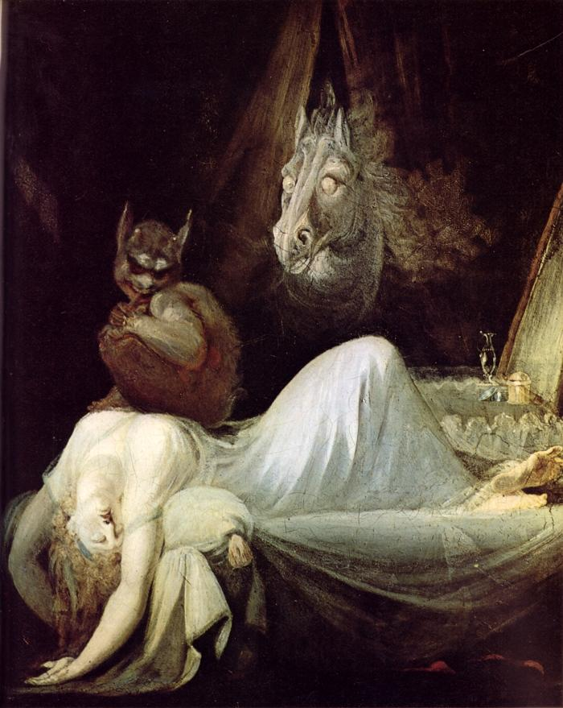

It was John Philpott Curran, the lawyer representing Rev. William in his trial for treason who was skewered in William Drennan’s description. No wonder Elizabeth may have felt the need to pander to him, but it seems that she did so with an artful touch: the fair dame, who I believe had studied human nature as much as her entertainer. This letter also offers the only description I have found of how Elizabeth presented in social circles. As: a very comely, clever, tonish woman.

Given that Elizabeth was still fertile in 1795, she would likely have been at least a decade younger than Rev. William. We have no window into the state of their marriage, let alone whether they had any understandings concerning fidelity. All we know is that they got married during the time when he took a clandestine trip from Paris to London in 1792.

Even though there are other references to Elizabeth having an affair, she remained a key player in Rev. William’s trial and was financially supportive while he passed his days in his jail cell, enjoying his bottles of claret and considering his likely impending death.

Jackson’s trial comes on sennight, And one who might be supposed to know says he will be found guilty. This is McNally, who tells everything. He says that the poor man is in tolerable spirits after his bottle. In the evening, talks enthusiastically, tells stories of the equanimity with which they meet death. In France - of Charlotte Corday, coming on the scaffold as if she was going to begin an opera dance - of a mother and two daughters from La Vandée being guillotined, when the youngest daughter stepped forward and said that she was first to be introduced (I forget the French term), and of Hébert lifting up his head to tell one of the guards, your turn is coming, and if female and male aristocrats die so, should not I show myself a true man? Jackson. has at least a true woman in one sense, if she be not a faithful wife, for Mac says she has sold the near reversion of £1200 for £300 to fee lawyers and for other expenses
The Drennan McTier Letters. Vol 2 1794-1801. ed Jean Agnew, 1999. Irish Manuscripts Commission, p. 107

Elizabeth’s financial hit of £900 amounts to the equivalent of about £173,409.19 today. Not to be sniffed at. Another description of her financial sacrifices may refer to the same loss, or else to another property (the described one-tenth of its value would add up to more than a loss of £900):

FRIDAY, 7th November. 1794.
The Court having sat, Mr. JACKSON was put to the bar, and the Sheriff of the city of Dublin was ordered to return his venire, which he did, and the Clerk of the Crown called it over.
Mr. CURRAN.—This trial was appointed for this day. It is more becoming, not to wait to see whether the counsel for the crown will say anything as to putting off the trial, but to state how my client is circumstanced. He has been in goal for many months. He was arraigned last term, when he pleaded, and the court were pleased to appoint this day for his trial. All the interval he has employed in the most deliberate preparations for his defence. Though a native of this country, his life has been spent out of it. He sent his wife to England to attend upon such witnesses as he thought necessary for the trial. She spent part of the summer in England where an agent was employed, and Mr. Jackson himself sent another upon the same business. These circumstances are ready to be proved by affidavit. Mrs. Jackson remained in England some time, and came back to prepare for the necessary attendance. Some property, which was the joint property of both, has been sold for about one-tenth of its value, to defray the expense of bringing over witnesses, who cannot be compelled to attend by any process of this court, and therefore then demands must be complied with
The Lives and Trials of Archibald Hamilton Rowan, the Rev. William Jackson, the Defenders William Orr, Peter Finnerty.. Thomas MacNevin Esq. Dublin. 1846 p.196.
Three affidavits were then sworn ; one by the prisoner, a second by his wife, a third by his agent, setting forth the endeavours which had been used to procure the attendance of witnesses, as stated by Mr. Curran.
The Lives and Trials of Archibald Hamilton Rowan, the Rev. William Jackson, the Defenders William Orr, Peter Finnerty.. Thomas MacNevin Esq. Dublin. 1846 p.199.

The record for this joint property, if found, could lead to another major breakthrough, especially if it was in the form of a marriage jointure, or if other family members were mentioned.

The impact of Rev. William’s trial and death on Elizabeth becomes clear in 1802, when she is living in Paris, flat broke. She feels abandoned and pleads with the French government. Two of her letters, written by her in French, but roughly translated by myself, are on my website. Unsurprisingly in these letters, the paternity of both children is attributed to Rev. William.

Doctor Jackson, my husband is condemned to death for having served the
French Government very well I pray [saisin = input?] and two
young children are the sole heritage that I have been permitted
to receive from him. Alarmed for their existence – I came
to France, to reclaim the benefits that were given to me
by the French Government, and it is to your Citizen Consul who
I address my humble claims. I continue to hope that
the one who dried up so many of my tears and stopped the
heart of the other of misfortune take pity on the deplorable
fate of a woman once so wealthy and now delivered to all
the bitterness of such a terrible situation. I would have suffered
in silence if I had only my misfortune to bear
but seeing my two children without help and support
is a torment that my heart cannot endure.
I implore your justice and I am solicitating a
place for my son, William Jackson age 13 years
in the Prytanée de Paris where he can learn to cherish
his Benefactor and a pension for sustaining my existence
and for my daughter [age 7 years] The reply which was made in your
name addressed to the Minister of Marine and that Minister
referred me to that of External Affairs but my steps
have all been unsuccessful and I have no more
than a single hope. Allow me Citizen Consul to expose
to your eyes a picture of my situation.
Having consumed my [financial?] means after a stay
of six months in Paris, I have come to a moment when it will be
impossible to exist, and to be able to have my children exist.
I have taught them the names of the heroes of France
and my heart tells me that he will come to the rescue of their unhappy mother
and cast a benevolent eye over her and them.
Hotel of Paris
Rue d la Roi
15 Sept 1802
I am Citizen Consul
With the most profound respect your
very humble and obedient servant,
Eliza Jackson

We must end – for now – with all that has been unearthed about Elizabeth JACKSON née BUNTING, but a few crumbs remain which might yet lead to finding out more about Rev. William’s first wife, the likely mother of William jr. Such crumbs do not amount to the equivalent of a loaf of bread, but still …

In a 1766, JACKSON’s newspaper The Public Ledger, mentions a Luke NAYLOR as the brother-in-law of Rev William. This Luke NAYLOR was likely the solicitor, born in 1750, who lived at Halfmoon Street Piccadilly in London and who died in 1814. His wife was Anne FARRELL. In 1809, he wrote a will, leaving all to wife Anne, his executor. There is mention of shares of a property in Ongar, in Co. Essex, as well as in Jamaica, the East Indies and Ireland, in his own name and in the name of William Burham, [illegible], William Ffarrell, Mary Ffarrall, Mary Shapcott, and Thomas Whitton. Several other friends are also mentioned, but the only mention of family is that of his wife.

The connection of Elizabeth JACKSON to this Luke NAYLOR becomes even stronger when we look at a map. Thanks to Laura McKenna who notes: It seems that Fyfield, where the Jackson's daughter was baptised in 1795, is only a few miles from both High Ongar and Chipping Ongar. So I think you are right about the Nailor/Naylor connection and that Eliza probably had the child baptised there on that account.

There is one more clue which buttresses the hunch of this connection. Some of the money spent on Rev. William’s defence, put up to cover witness costs, went to Mr NAILOR, an English agent. It is likely that he was the same Luke NAYLOR, the brother-in-law.

Mr. Curran.—A considerable sum of money was paid to defray their expenses, and certain matters of record are to be brought upon a security of £500 for their being returned. Mr. Nailor, an English agent, has them in his possession, and he was expected here by this time. He is a material witness, and his arrival with the others was expected:—they are not yet arrived. There appeared a paragraph in the English newspapers, that this trial was put off to the 21st instant. Mr. Jackson states that his witnesses might be led into error by this publication, which was made without any connivance, or privity of his. The Lives and Trials of Archibald Hamilton Rowan, the Rev. William Jackson, the Defenders William Orr, Peter Finnerty.. Thomas MacNevin Esq. Dublin. 1846 p 197.

Mr. Jackson.—My Lords, the impression I would wish to leave on this court is, that notwithstanding four months might appear sufficient for preparation, yet with the utmost exertion, I have not been prepared. Ten days after my trial was postponed, I put matters in arrangement; every exertion was used to bring over the witnesses and documents ; notices were served upon certain persons in England to produce certain documents, or correspondences relative to my conduct :—These have not been brought over, and the agent in England has been so grossly imposed upon, from the idea that the trial was put off, that he wrote to my wife that he would not come over, until he heard from me. Why this paragraph was put into the papers in England, and copied into the papers in this town, I cannot say. I never felt a greater disappointment in my life than in not being tried this day. The Lives and Trials of Archibald Hamilton Rowan, the Rev. William Jackson, the Defenders William Orr, Peter Finnerty.. Thomas MacNevin Esq. Dublin. 1846 p 198

The phrase the devil is in the details (attributed to Nietzsche) probably originates from the earlier phrase God is in the details, meaning that whatever one does, do it thoroughly. So, stay tuned. Perhaps this post will spark further discussion and insight. Perhaps the story might even get turned into a novel - another and sometimes higher kind of truth. For now, I am keeping my sights on Mr. Tighe. He and Elizabeth may have been living at Stephens Green. He appears in one last bit and once again his forename was not included. Hmmm:

Jackson's funeral was well attended by numbers of the United Irishmen. Barrington says, " he had a splendid funeral, and, to the astonishment of Dublin, it was attended by several members of parliament, and barristers ! A Mr. Tighe, Counsellor Richard Guiness, (Sir Jonah might have added the two Sheareses, also members of the profession), were amongst them." It is unnecessary to remark, that Barrington was too consistent a patriot to be of the number of those who, as was said in the House of Commons,[ Debates of the Irish House of Commons, June, 1795] " paid the honours of treason" to the unfortunate Jackson.
He is buried in the churchyard of St. Michan's, where also are interred the remains of Oliver Bond, and of Henry and John Sheares.
The Lives and Trials of Archibald Hamilton Rowan, the Rev. William Jackson, the Defenders William Orr, Peter Finnerty.. Thomas MacNevin Esq. Dublin. 1846 p 185

LATE BREAKING NEWS.
Thanks to a recent email from Laura McKenna, we now know that in 1827 Elizabeth Jackson and her son were both living in Livorno, a port on the western shores of Italy. This reference (Laura thanks the work of Dr. Jennifer Orr for this source) was contained in a letter from Amelia Curran to David Baillie Warden (ex-United Irishman, American consul in Paris and a man with an incredible political and cultural correspondence):. I suppose you hear from the Jacksons sometimes. I went to Livorno to pay a visit two years since to Mrs Jackson. She seemed ill and was afterwards I understand much worse, her son was here but I did not meet him as he was married or almost as bad – alas.

In a subsequent email, Laura added a bit more information: Amelia Curran was an artist who painted Percy and Mary Shelley, and [she was] the daughter of John Philpot Curran, one of Jackson's defence lawyers in 1795.

The fact of Elizabeth and her son being in Italy is a good fit with a bit in my 2019 blog post, Rev. William Jackson & his Gore ancestry: Rev. William Jackson’s only son. also named William (last sighted in Rome in 1739, age 49). That reference (which I hadn’t cited) came from The United Irishmen: Their Lives and Times. Richard Robert Madden, The Shamrock edition, Newly Edited With Notes, Bibliography And Index By Vincent Fleming O’Reilly, The Catholic Publication Society 1916. p 188. What became of the widow of Jackson I have never been able to learn, but in 1839 Dr. M’Neven informed me that there was a son of his then residing in Rome, NOTE: Richard Robert Madden was born in 1798, and his book was originally published in 1857, so he was not a contemporary witness. It is likely that Elizabeth was no longer alive when he was doing his research. Also, since he was known for a certain laxity in citing sources, and destroyed some of his research documents, it is always reassuring to find additional confirmation of his claims.

As always, with research like this, it takes a village. In this case, it is a village of mostly women.

For my earlier related posts, see:

- Rev. William Jackson & his Gore ancestry 2019
- Dr. Richard JACKSON (abt 1720-abt1768) and the SALEs. 2019
- Rev. William JACKSON - Dead Ends Blog #1 2019
- Hyde’s Coffee Shop 2019
- Documents relating to the ancestry of Rev. William JACKSON. 2019
- Richard Jackson father of Rev. William JACKSON (1737-1795) 2021
- The wives of Rev. William Jackson (1737-1795) 2021
- Rev William Francis JACKSON 2023

DELETED
There is a whiff of condescension in the reference to Rev. William Francis JACKSON (1737-1795) as Parson Jackson. It may have been no more than condescension rife amongst the upper-class of the Established Church of the day in England towards ordained members of their church who leaned towards the more Protestant side of things, and worse – who were Irish.

