REV. RICHARD JACKSON (1602-1681):

It took a lot of luck and moxie for Rev. Richard JACKSON (1602-1681) to protect his twenty-three children in England and Ireland throughout the cultural-financial-religious turmoil of the mid-1600s. When the battles between the Royalists (Established Church) and the Parliamentarians (Puritans) were at their peak, his political and religious shifts show him to be an ideologically nimble cleric. Not unlike the Canadian hockey legend Wayne Gretzky, he learned how to Skate to where the puck is going to be, not where it has been. In the mid-1600s, this meant sometimes skating towards the faith of the Puritans (when advantageous), or toward the Royalists (depending). Following the hockey metaphor, imagine him digging in with the inside edges of his skates, leaning into the turn and using the friction to pivot and change direction.

But sometimes, it can still be possible to take a fall.

Born as a son of William JACKSON, a well-heeled merchant of Kirkby Lonsdale, one could be forgiven for thinking - based on the assets in his father’s bequests [1626 April 20 Will of William JACKSON] - that he would have been financially insulated from taking a a career-decking hit, but he wasn’t. He was facing financial ruin because he had loaned a significant sum of money to a popish recusant. After the anti-Catholic laws were enacted and then effectively enforced, this person had no way of paying him back. In 1645, Rev. Richard appealed to Col. BENSON, a friend (or at least acquaintance) with close connections to Oliver Cromwell. As BENSON put it:

…. I am intreated by two speaciall friends to the cause to write to yor Lorp in ther behalfe. I make bold to do it knoweing yor Lorps readynes & noble disposition to here & help honest men, in any lawfull & faiseable mattr. First one Mr. Jackson ministr of Whittingham neare Kyrby Lonsdall, a vry pious & honest able man haveing heretofore entred bond as surety wth a popish recusant (I psume it was wth hopes to gayne him to or Church) principall for the sume of 100£, this was donne before these troubles, & the popish gentleman proveing a Delinquent all his lands & meanes beinge sequestred, is utterly disabled to satisfy that debt, whereuppon honest Mr. Jackson is like to beare the burden, but I feare it will breake his backe & the creditours (now tyme begineing to be open (?) in Lancashire where Mr. Jackson lives that suites may be tryed) doth labour to pursue Mr. Jackson & recovr his 100£ of him wch indeed is easyly done for the bond is cleere. Yet if lawe pceede agaynst Mr. Jackson & compell him to pay it as it will do, he will "be undone, and not able to subsist haveing wife & many children, 14 children he hath & the 15th (is by this tyme borne for every houre his wife lookes for it) this is this honest ministrs desire & I earnestly desire the same, that yor Lorp be pleased to advise his friend (that will repaire to yor Lorp) what course may be taken that Mr. Jackson may have satisfaction, if any be to be had out of the delinquents estate of lands or woods, or any way whereby himselfe & the publike be not priudiced, we leave it to yor Lorps wisdome, & information of any that shall be imployed to come to yor Lorp. I am sure if yor Lorp can help him you shall not neede repent of it he is so honest a ministr. SOURCE: The Ejected of 1662 in Cumberland and Westmorland. p890: 1645 Feb 28: Letter from Right Honrable Col. Benson

Given the outcome, BENSON’s intervention seems to have saved Rev. Richard from ruin.
Since the intent of the loan had been wth hopes to gayne him to or Church principall, it seems most likely that the popish recusant who had incurred the debt was the Catholic landlord who was also the advowson of the Whittington Parish. The conflated roles of advowen (the power to appoint priests) with that of landlord had originated from the practice of landlords donating lands for parish churches, and then as recompence being given certain powers. Of course, this got rather dodgy when the advowsen was personally affiliated with and held to a faith that diverged from the politically permitted faith of the time.

In the case of Whittington Parish, Thomas CARUS, the patron of Whittington, had in 1735 been convicted of recusancy, meaning that he had refused to attend Established Church services, and as a consequence would have ended up having all his lands & meanes beinge sequestered during the First English Civil War Decades later, the transfer of his patronage to Edward Middleton, as a work-around - was alleged to have been collusive. [SEE: British History: Whittington]. Although instances of Established Church parishes being owned by a Catholic landlord was not common, neither was it unheard of. Power, as always, tends to shapeshift according to need.

Churches had embarked on their own shapeshifting. Rev. Richard must have survived that crisis because he was still employed as vicar of Whittington when on Oct 2, 1646, a year after he had faced financial ruin, he subscribed and signed on to the protest of Lancashire ministers against toleration of strange doctrines (meaning tolerating Presbyterian and other dissenting preaching within the established church).

The non-conformist's plea for uniformity : being the judgement of fourscore and four ministers of the county palatine of Lancaster, of a whole provincial assembly of ministers and elders in and about London, and of several other eminent preachers, English, Scottish and New-English, concerning toleration and uniformity in matters of religion : together with a resolution of this difficult question, whether the penalty of the law ought to be inflicted on those who pretend and plead conscience in opposition to what the law commands?
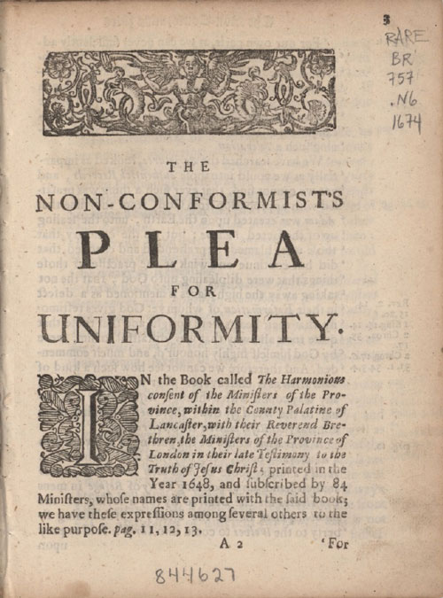

His step away from the tenants of the Established Church made tactical sense at the time, although the term Puritan was more inclusive than it might seem to many readers of history (aka me) since it applied to anyone who wanted to purify the Church of England of Papist practices. This left some wiggle-room for Presbyterians and other dissenters to back away from the Established Church but still maintain some establishment political alliances. For example, a John JACKSON b 1570 of Melsonby Yorkshire was described as a Puritan, but he was also a known Royalist. [SOURCE: Alumni Cantabrigienses]

The non-conformist's plea for uniformity : being the judgement of fourscore and four ministers of the county palatine of Lancaster, of a whole provincial assembly of ministers and elders in and about London, and of several other eminent preachers, English, Scottish and New-English, concerning toleration and uniformity in matters of religion : together with a resolution of this difficult question, whether the penalty of the law ought to be inflicted on those who pretend and plead conscience in opposition to what the law commands?

With the Restoration of the Monarchy, Rev. Richard tailored his beliefs to resume his allegiance to the Established Church. The bequests itemized in his 1679 January 15 will indicate that this had paid off. He died with an abundance of leases and several gold coins, one of which was engraved: In Hoc Signe Vinces In this sign you will conquer.

Although Rev Richard’s twenty-three children and their Irish descendants were generally regarded as Church of Ireland, many in fact were Presbyterian (or both/and), and a few even registered themselves as Catholic (often as a result of a marriage). For the latter, forenames such as John morphed into Sean. The family continued to practice a flexible and pragmatic approach when it came to both religious and political faith. They were not alone. The Clothworkers held on to their holdings in Derry by also placating the players on both sides of the fence.

The Livery Companies were often viewed as a source of ready cash by the monarchy and during the political troubles of the seventeenth century they received many demands for money; in 1640 and 1641 alone these requests exceeded £10,000. Unable to meet the King’s precepts, the Company was forced to borrow from individual members. When Civil War erupted in 1642, further demands arrived, now from Parliament and the City.
…
During the Civil War, the Clothworkers sided with Parliament, as did the City – indeed, the Master of the Company in 1652-1653 was Alderman Sir John Ireton whose brother, Henry Ireton, had signed King Charles’ death warrant – however, the Company was quick to shift allegiances when required. At the restoration of Charles II in 1660, they went to great effort to welcome the King into the City with suitable splendour. The Company’s trumpeter was lent to the Guildhall; six handsome, tall and able men were lent to serve the meat; £165 was given towards the cost of the banquet and members lined the streets in their finest attire with cloths, banners, streamers and ornaments resplendent around them.
SOURCE: The Clothworkers Company Timeline.

SEE ALSO:
- ‘The public profession of the nation’: religious liberty and the English Church under Oliver Cromwell. Anne Hughes.
- Petitioning for the settling of the Church: The Lancashire and Cheshire Presbyterian
- campaign of 1646 and the politics of accommodation.
- The Restoration of the Church of England, 1660–1662: Ordination, Re-ordination and Conformity

