Who was Robert HYDE of Hydes Coffee Shop Part One
- Richard Jackson father of Rev. William JACKSON (1737-1795) 2021
- The wives of Rev. William Jackson (1737-1795) 2021 Other bits of the story which still niggle at me:
- Who was William's first wife? She died of cancer, but when? He was supposedly devoted in his care of her.
- · In a 1766 mention in JACKSON’s newspaper The Public Ledger, a Luke NAYLOR is mentioned as JACKSON’s brother-in-law. He was probably the Luke NAYLOR, born in 1750, a lawyer who lived at Halfmoon Street Piccadilly in London and who died in 1814. His wife was Anne FARRELL. Perhaps William's first wife was a sister of Luke NAYLOR. Another possibility is that JACKSON had a sister who had married a NAYLOR. No sisters are mentioned in William's early bios (just that he had three older brothers), but the non-mention would not be surprising given the general invisibility of women in the records of the day. Update Jan 23, 2024: The Times Feb 3, 1795: Dublin Jan 27, 1895, A Mr. NAYLOR, a London Attorney of Westminster Hall, was Rev. William JACKSON's lawyer representing him at his trial at the Court of King's Bench. The trial was delayed until the next term.
- Documents relating to the ancestry of Rev. William JACKSON. 2019
- Rev. William Jackson & his Gore ancestry 2019
- Hyde’s Coffee Shop 2019
- Dr. Richard JACKSON (abt 1720-abt1768) and the SALEs. 2019
- Rev. William JACKSON - Dead Ends Blog #1 2019
- Rev. William Francis JACKSON 2023

Robert HYDE was the owner of the Coffee Shop at the corner of Dame and Palace Street in the late 1700s, and on April 1795 Rev William JACKSON (1737-1795) was arrested there and charged with treason. You might think that there might have been something about HYDE and his connection to all this. Instead, crickets. His shop had just opened its doors a mere three months before Rev William’s arrest and had been staying in rooms rented above the coffee shop, hence likely with HYDE’s full knowledge. Since Rev. William was found guilty of collusion with the French on behalf of the United Irishmen, part of the plan to end the British control of the Irish Parliament, key questions arise:

Was Robert HYDE just as sympathetic to the cause of the United Irishmen? Did he have any ancestral or business connections with Rev. William? After all: birds of a feather nest together. Did Rev. William lodge with HYDE for other reasons? Location, for example?

I asked these same questions five years ago in a post on Hyde’s Coffee Shop: Since then, I have teased out more bits and feel ready to wager that hunches about their prior connections are worth betting on. A compelling starting point is the ad where HYDE was seeking subscribers to his Coffee shop, an ad placed in the Dublin Evening Post on January 11, 1795. This was a little over eight months after Rev. William was arrested while staying there on April 28, 1794 and three months before his death.

INSERT JPG of Ad
PROPOSITION
FOR THE ESTABLISHMENT OF
A NEW COFFEE HOUSE,
ENTIRELY ON THE
LONDON PLAN,
At the Corner of Dame-Street. and Palace-Street.
_____
ROBERT HYDE,
Being about to resign the Tea Trade, has, at the suggestion of his friends, resolved on converting his present extensive shop into a public coffeehouse, by SUBSCRIPTION; Provided his plan is honored with adequate encouragement.
The establishment is to be open on the plan of the London COFFEE-HOUSE. The lower part to be appropriated as a Coffee-room, where the usual refreshments of Tea, Coffee, Soups, Jellies, etc, will always be provided in the very best style. The most respectable London, and all the Dublin NEWSPAPERS AND MAGAZINES, with the Day-Notes, Prices Current, Lloyds Lift, and the Sailings, and Arrivals of the Port of Dublin, will be regularly filed; and every endeavour exerted to render this Coffee-house a prompt and authentic force of the earliest intelligence, whether Commercial, Political, or Literary.
A spacious apartment will be entirely devoted for the use of subscribers desirous of being retired on business.
The upper part of the house to be appointed as an Hotel, the apartments fitted up in a neat style, and let on moderate terms to weekly lodgers, who may be accommodated with dinners.
SUBSCRIPTION ONE GUINEA PER ANNUM.
The situation is presumed to be unexceptional; and on an obvious want of such an establishment in Dublin, it must be unnecessary to comment with any man of experience or observation.
The DIRECTOR fully sensible of that want, and hoping that proper exertions to merit it, by an eligible establishment, can scarcely fail of due encouragement in this rising metropolis, respectively solicits the support of his fellow citizens.
The Subscription book is now opened as above; the preparations for opening the coffee room are considerably advanced.

The typical London COFFEE-HOUSE was designed to meet the needs of a prosperous clientele, hence the newspapers and Commercial, Political, or Literary intelligence and such. In the cartoon beneath, note all the wigs and then – later, when looking at leases of this era - note how often the profession of Peruke maker crops up. More than one might think.

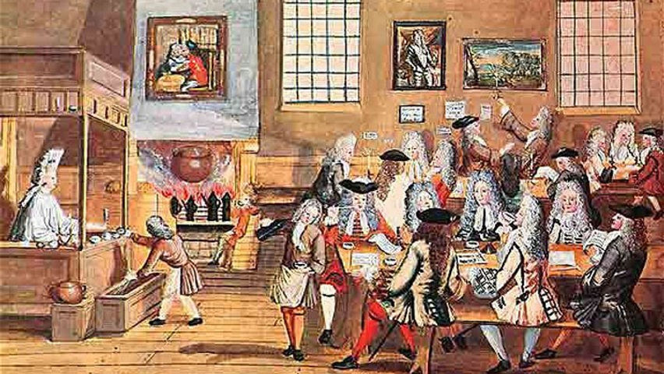
SOURCE: The Devil’s Drink and Disturber of the Peace: The History of Coffee in Ireland
… the coffee house was probably the best way to get up to date news in Dublin during this period, with sailors, merchants and politicians in the know all congregating and swapping their stories. Aside from this, most coffee houses had a good relationship with printers and always had a supply of the latest newspapers and pamphlets for their patrons to enjoy.

If you could stand at the corner of Castle Street and Dame, in front of the current Allied Irish Bank built in 1872, you would be right in front of where Hyde’s Coffee Shop once stood,. Location, location, location (as realtors tend to say). Reflect then, on the reality that a decent hurler could hurl a stone in the direction of the Castle – the nerve centre of power in Ireland - and easily knock down one of the many bewigged and begowned parliamentarians as they traipsed in and out of the courtyard. It Think what could be done with more than a hurley stick.

The ad nails down the time-frame wherein it began and that it was funded by subscription, deeds work related to its ownership raises other questions. Was Robert HYDE related to the previous owners: John HYDE and his wife Sarah RAY? They were printers, publishers and booksellers in Dublin in the late 1600s and early 1700s. Not only was the printing business also subscription-based, and not only did they own the exact site on Dame Street as well as four neighbouring sites which before that had been owned by Sarah HYDE’s father, the feisty printer Joseph RAY.

Even though scrolling through decades of leases can become mind-numbing, a hop-skip-and-jump through decades of ownership gives a sense of previous intergenerational hand-overs which I suspect will lead us to the Robert HYDE of Hyde’s Coffee Shop.

1749 is the earliest lease showing Sarah HYDE owning the south side of Dame Street. NOTE: I suspect the clerk recording the name JUDD should have recorded RUDD – a name that crops up in relation to this property in similar deeds.
1749 Aug 7
ROD: 134-518-91973
Image 292
Sarah HYDE of Dublin widow demised to Robert HIGGINS of Dublin Apothecary front Dwelling House or tenement with yard of backside back house & offices of Garden behind same on southside of Dame Street Dublin Bounded on east to Mr. HUGH’s holding west to Mr NEILL’s holding south to Mr. JUDD’s holding north to King’s Pavement & also stable on the east side of said garden bounded east by Mr CHAIGNEAUSS concerns west by said garden North by Mr McROBINS’s holding & south by a passage leading from said garden to Trinity Lane & Pye Corner with Liberty of Egress or Regress … for next 99 years … WITNESS: Henry STEARNE Clerk to Christopher DALTON.
NOTE: Sarah HYDE née RAY (bef 1700-1750) Printer and widow of John HYDE (bef 1700-1728). In March 1749, Sarah HYDE left off her business and sold her stock. She died Nov 15, 1750. SOURCE: A Dictionary of members of the Dublin book trade. 1550-1800. Based on the records of the guild of Saint Luke the Evangelist. Dublin. M. Pollard. London Biographical Society. 2000.

Ten days later, a lease of the same property also mentions a lot on James Street. Tracking such pairings of properties can reveal much about inheritances and intergenerational connections:
1749 Aug 17
ROD: 177-187-117980
Image 426
Sarah HYDE of Dublin Widow Did Sett unto Robert HIGGINS of the same Apothecary All that front Dwelling House or Tenemt with the yard or Backside Backhouse out offices & Garden behind the same situate on the South side of James Street Dublin - Bounded as therein ment & also all that Stable situate on the East side of the sd Garden Bounded as therein ment with full & free Liberty of Egress & Regress in & through a passage leading from sd Garden to Trinity Lang & Rye Corner at all times during that Demise with the Appurs & the use & wear of the Severall Goods & particulars mentioned in a Schedule to sd Lease Annexed To Hold sd House yard or Backside Backhouse out offices & Garden from the 29 Sept then next Ensuing for 99 years & to Hold the said Stable & passage from the sd 29 Sept then next for the Like term of 99 years provided the term & In which the sd Sarah HYDE her Exrs Admr & Asst then had or at any time - - thereafter should have to come therein should so long continue at the yearly Rent of £40 Ster payable half yearly above Taxes and by sd Assignment the sd Robert HIGGINS in consider of £60 to him paid by Benjamin RUDD of Dublin Carpenter Did afore - Assign & make over unto sd Benjamin RUDD All that the sd front Dwelling House or Tenement with the yard or Backside Backhouse out offices & Garden behind the same situate on the South side of Dame Street Dublin & also the sd Stable Situate on the Eastside of the said Garden & all other the premes demised by sd Lease with the Appurs To hold unto the sd Benjamin RUDD his Exr Admr & Asss from thenceforth during all the Residue & Remr of the Terms then to come by sd Lease Granted Subject to the Rent & Covenants WITNESS: Samuel SIMMONS of Dublin Sadler & William WILLIAMS Clerk to Christopher DALTON of the same Publick Notary Robert HIGGINS [SEAL]

Eight years later, Dame Street properties are included in the marriage agreement for Mary HYDE, one of Sarah HYDE’s daughters. In earlier, Sarah HYDE owned several lots on the north side of Dame Street, right across from the future coffee shop. Stick a pin in the properties mentioned in Co. Tyrone, as well as the Severall Houses in Dame Street Trinity Lane Chequer Lane and Clarendon Street.

1757 Oct 15
ROD: 188-346-125934
Image 193
Mary HYDE of the City of Dublin Spinster of the first part George ESDALL of the same City Gent of the second part and Constantine BARBER of the City of Dublin Esqr Doctor of Physick and William WHITE of the City of Dublin aforesaid Merchant of the third part Reciting that Hester KINGSBERRY (KINGSBURY) of the City of Dublin Widow being possessed of the Towns and Lands commonly called and known by the names of Drungarge [probably Drumderg, Parish Clonfeacle (Tyrone portion)] Drumlee [Drumlee, Parish Clonfeacle (Tyrone portion), Barony Dungannon Middle] Derryoghill [?] Tullylearn Tullylearn [Tullylearn, Parish Clonfeacle (Tyrone portion), Barony Dungannon Middle] and Tullydowey [Tullydowey, Parish Clonfeacle (Tyrone portion), Barony Dungannon Middle] in Co. Tyrone by virtue of a Lease from and under the see of Ardmagh on by Indenture of Lease demise the said Towns and Lands unto Sarah HYDE late of the City of Dublin for a term of years with a covenant of Renewal and under the yearly Rents and covenants in the said Indenture of Lease mentioned and that the said Mary HYDE as one of the children of the said Sarah HYDE is now intitled to a share & proportion of the said Towns and Lands by virtue of the said Demise made by the Hester KINGSBERRY to the said Sarah HYDE and that the said Mary HYDE is also intitled to share and proportion of and in several House Holdings and Premisses six in Dame Street, Trinity Lane, Chequer Lane, and Clarendon Street the said premisses in Dame street now in the occupation of Mr James RUDD the premisses in Chequer Lane held by Mr Nicholas ENGLISH those in Clarendon Street now or Late in possession of Mr. Thomas NEWTON and those in Trinity in the possession of John CHAIGNEAU Esqr Mr. Murtogh LAY and the parish of St Andrew 's Dublin by virtue of and in several Leases for years made of the said Premisses which are yet to come and unexpired and Reciting that a Marriage was then shortly to be had between the said George Esdall and Mary HYDE whereby the said Mary HYDE for the considerations therein mentioned did grant assign and make over unto the said Constantine BARBER and William WHITE all her Share and proportion of of and in the said Lands of Drungorge Drumlee Derryoghill Tullylearn and Tullydowey and also of and in the said Severall Houses in Dame Street Trinity Lane Chequer Lane and Clarendon Street with the appurtenances thereto belonging To hold during the several Terms for year granted or to be thereof To and for the several use and purposes therein particularly mentioned and the said George ESDAL did thereby further covenant that in case the said Mary survived him having issue then living then she should be intitled to receive one third part of the real and personal Estate whereof he should dye seized and in Case of no such Issue then to two thirds WITNESS: Susannah HYDE sister of the said Mary HYDE and by Christopher DEEY Publick Notary City of Dublin and this memorial is also witnessed by the said Christopher DEEY and Rebecca DEEY his wife George EDSALL [SEAL]
NOTE: My current best guess is that Hester KINGSBURY (1705-btw 1758-1763) , wife of Dr.Thomas KINGSBURY (1688-1747) was born either as Hester HYDE or Hester RAY and that the roots of their family were in Co. Wexford.

The KINGSBURY-HYDE properties were passed down through many generations. Not to go too far down a rabbit hole, but … Oscar WILDE was a g-g-grandson of the Dr. Thomas KINGSBURY (1688-1747), husband of Hester aka Esther KINGSBURY mentioned in this deed. The title to the Tyrone lands which she had title to likely originated with Joseph RAY, father of Sarah HYDE. He was a publisher and bookseller from the mid to late 1600s. A little over a hundred years later, the same Co. Tyrone townlands are grouped together and included in a Deed by Sir William Robert WILDE:

1866 Jul 31
ROD: 1866-32-6
Image 428
BTW Sir William Robert WILDE of Merrion Square in the City of Dublin Knight Emily Thomazine WARREN otherwise ELGEE widow of thirteen Cambridge St High Park London the Revd William MATURIN of Grange Gorman Glebe County Dublin Clerk and Thomas Edmund MIGHT of Upper Marion street City of Dublin Solicitor of the one part and Charles MAGEE of Armadall cottage County of Dublin Esquire and Elizabeth Isabella MAGEE of Dalkey County Dublin Spinster of the other part. Reciting Indenture of lease by way of Renewal 18 Sept 1847 made between Sarah ELGEE widow and Letitia KINGSBURY Spinster and Henrietta MATURIN of the one part and the said Charles MAGEE and Elizabeth Isabella MAGEE of the other part and which lease was made in pure of a toties quoties covenant contained in an original lease 1 Aug 1838 BTW Thomas KINGSBURY of the City of Dublin Esquire M. D. of the one part and Sarah HYDE of the said City widow and executrix of John HYDE late of City of Dublin deceased of the third part [NOTE: The year given for the original lease is dubious. Dr. Thomas KINGSBURY married 24 Aug.1728 and died in 1747 while John HYDE died in 1728.SEE: 1728 Aug 4, ROD: 57-317-38666 where the six townlands mentioned beneath are also mentioned] and after further reciting as therein said Indenture of which this is a memorial witnessed that the said Sir William Robert WILDE Emily Thomazine WARREN [née ELGEE] William Maturen and Thomas E WRIGHT … set and to farm let unto the said Charles MAGEE and Elizabeth I. MAGEE their exors admors and assigns all those the said six townland or Ballyboes commonly called or known by the name of Tullikean [possibly Turleenan, Parish Clonfeacle (Tyrone portion), Barony Dungannon Middle] Tulladuffe [Tullydowey (Tulaigh Dubhthaigh), Parish Clonfeacle (Tyrone portion), Barony Dungannon Middle] Drundarge [Drumderg, Parish Clonfeacle (Tyrone portion), Barony Dungannon Middle] Stange [either Stangmore (Knox) and/or Stangmore (Magee), both in Parish Clonfeacle (Tyrone portion), Barony Dungannon Middle], Drumley als Fullanckelly [Drumlee, Parish Clonfeacle (Tyrone portion), Barony Dungannon Middle], and Drumgoon [probably Derrygoonan, Parish Clonfeacle (Tyrone portion), Barony Dungannon Middle] demised by the said lease of renewal of the 18 Sept 1847 known or described situate lying and being in the territory of Clonfeacle [Clonfeacle (Tyrone portion)] County Tyrone … reserving unto the said Sir William Robert WILDE Emily Thomazine WARREN William MATURIN and Thomas Edward WRIGHT their exors admors and assigns 2a 2r of Bog in the townland of Drumgoon surrendered on the occasion of a previous renewal 10 Feb 1842 … WITNESSES [various witnesses used for different signatures]: George CROZIER of Alfork Street City of Dublin Col , William O NEILL Clerk to M GAUSSEN and son solicitors Gardiners Place City of Dublin and Arthur TODD of Lower Bagget Street City of Dublin solicitor and James E. MOORE of Russia street City of Dublin Gentleman and Charles INGLIS of Waterloo Street Brighton England a captain in the Royal Navy and as to the execution of said deed and John SCANLAN of No 5 Charlemont Parade Dublin law clerk , Sir William Robert WILDE [SEAL]

To sum up, decades before Robert HYDE opened his coffee Shop, the site and its buildings had been owned by Sarah HYDE, a member of a family that he was likely related to. Back to the tale of the Coffee Shop.

Four months after the arrest of Rev. William, Robert HYDE leased it to Valentine DOWLING on the basis on annual renewable rents. Were his reasons financial, political or a mix of both?

1794 Sept 1
ROD: 500-132-312379. Palace Street
Image 398
BTW Robert HYDE of City of Dublin Coffee House Keeper of 1 pt & Valentine DOWLING of City of Dublin of other pt. Reciting that in Consideration of £250 paid by DOWLING, HYDE assigned to DOWLING in his actual possession… the house known by the name of Hyde's Coffee No. 7 Dame Street the Corner of the Palace Street with the appurtenances and several articles of Household furniture .. for three lives or 100 years subject to the payment of rent… WITNESS James O'BYRNE of City of Dublin Esq. & Mr. Daniel Mark CONNER of Beresford Road

Five years later, another lease connecting Valentine DOWLING to Robert HYDE reveals the where Robert HYDE and Valentine DOWLING were residing. HINT: Not at the Coffee Shop:
1799 Aug 21 (NOTE: As it was recited in the memorial beneath - recorded 1814 Jan 5)
ROD: 671-226-461122
Image 128
Valentine DOWLING of Palace St. in the City of Dublin of 1 pt; James SCOTT of Grafton St in the City of Dublin watch & time pieces maker of the other part. Reciting of Lease 21 Augt 1799 Edward KEOGH of Whitehall in the County of Dublin Farmer demised to Robert HYDE then of Gowans [sic SEE: John GRENHAM: Gordon's Lane in St Peter civil parish, Dublin city] the said Coy Gent the [?] occupied of Michael RUFFAN contain 5a in Parish of Tawney [probably Taney ] Co. Dublin being part of Land of Dundrum [Dundrum, Parish Taney, Barony Rathdown] to hold to said Robert HYDE his Exors admors for the tern 177 years from the 25th March their part at the yearly rent of £39 reciting , that said Pieces had by an assignes tenure unto the said V DOWLING also all that DOWLING had agreed to make or all his Estate and within said ground in James SCOTT in consideration of the sum of £800 … granted to Joseph SCOTT all that and those the field formerly in occupation of Michael REGAN Bounded on the North by the road leading from Dublin to the new Dargatle by the Land of Kingston on the East by the New Lott which divides the land of Ballally [Balally, Parish Taney, Barony Rathdown] from the land of Ballintin [Ballinteer, Parish Taney, Barony Rathdown] and [?] and on the west by Mr QUILLs [?] holding containing 5 acres in the Parish of Tawney Co. Dublin being part of the Lands of Dundrum with the Dwelling house offices Garden and appurs belonging to James SCOTT … WITNESS: James H. WALKER of the City Dublin attorney at Law and Richard MYLETT writing clerk. Clerk Val DOWLING [SEAL]

The lands leased at Dundrum, Parish Taney, Barony Rathdown will become key to tracking down more of the story. Later. Another lease, four days after that lease, verifies that Robert HYDE was indeed residing on Gordon Lane:
1799 Aug 25
ROD: 577-510-390508
Image 576
Endorsed on a lease dated 1799 Aug 25 BTW Edward KEOGH of White Hall Co. Dublin farmer of 1 pt & Robert HYDE of Gordon lane [SEE: John GRENHAM: Gordon's Lane in St Peter civil parish, Dublin city] ] in said County Gent of the one other part By which lease KEOGH demised unto the said Robert HYDE all that and those that field then lately in the Tenure and occupation of William KEEGAN bounded on the North by the road leading from Dublin to the new Dargle on the South by the Lands of Kingston on the East by the Rivlet which divide the Lands of Ballally [Balally, Parish Taney, Barony Rathdown] from Lands of Ballinter [Ballinteer, Parish Taney, Barony Rathdown] and Mr. FORTESCUE’s Holdings and on the west by McGUIRK’s containing 5a in the Parish of Tawney County of Dublin aforesaid and being part of the Lands of Dundrum [Dundrum, Parish Taney, Barony Rathdown] … at the yearly rent of £300 payd quarterly and by the said deed poll or assignment of this is amend the said Robert HYDE for the Consons therein mented sold assigned and made over unto Valentine DOWLING of the City of Dublin Gent … for the residue then to come and unexpired of the said term of 77 years WITNESS: Terence CONNELL Shoemaker and Thomas VINEENY Gent both of the City of Dublin and his memorial is witnessed by the said Thomas SWEENY and John DOWLING of the same City Gent Valentine DOWLING [SEAL]

The lands leased in 1799, were back in the hands of Robert HYDE, and were advertised to be leased again. SOURCE: Saunders Newsletter, 1803, Feb 1st, Robert HYDE leased the lands of Dundrum [Dundrum, Parish Taney, Barony Rathdown]. NOTE: The 5a of meadow [in Balally, Parish Taney, Barony Rathdown] from Lands of Ballinter [Ballinteer, Parish Taney, Barony Rathdown] becomes significant later in legal cases.:
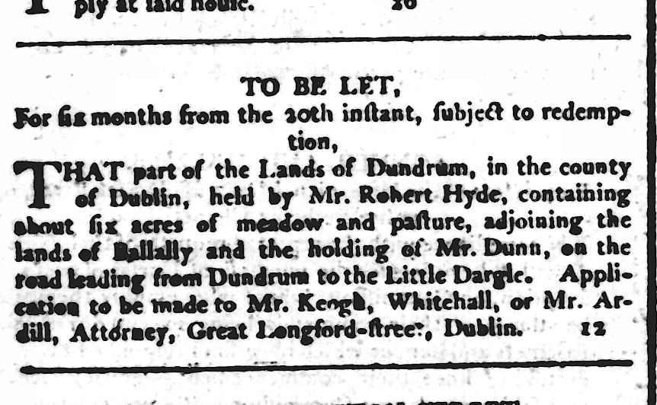

Six and a half years later, Robert HYDE is again linked to Valentine DOWLING, this time with the addition of a Richard HYDE as an owner. I have double-checked my transcription, and the name Richard HYDE is as recorded. There is a possibility that this was a clerical error and that another Robert HYDE assigned the lease to a 2nd Robert HYDE (or else that this Richard HYDE is even better at hiding from the written record than Robert HYDE was):
1806 Feb 9
ROD: 578-561-390624
Image 293
BTW Valentine DOWLING of the Co. of Dublin Gent of the one part and John HOGAN of the same City Victualler of the other part whereby Valentine DOWLING granted in Mortgage to John HOGAN field formerly in the demise & occupation of Michal HOGAN Bounded on the North by the road leading from Dublin to the New Dorgh on the South by the hands of Kingstown on the East by the Rivulet which divides the lands of Ballatly [Balally, Parish Taney, Barony Rathdown] from the Lands of Ballintur [Ballinteer, Parish Taney, Barony Rathdown] and Mr FORTESCUE’s holdings and on the West by Mr GRANT’s holding Containing 5a in the Parish of Tawney [probably Taney ] Co. Dublin of being part of the Lands of Dundrum [Dundrum, Parish Taney, Barony Rathdown] together with all houses out offices Buildings & Improvements made & erected on the premis & Appurs thereunto belonging To hold from thenceforth for the residue then unexpired of the term of 77 years granted of the so promes by virtue of a Lease dated the 21st day of August 1799 made by Edward KEOGH to Richard HYDE & after assigned by the sd Robert HYDE to the sd Valentine DOWLING as in the penalty last subject to the yearly rent of £30 and Covenants … WITNESS: William Agustus WALKER and John D DOWLING both of the City of Dublin Gent Val DOWLING [SEAL]
NOTE: Woodpark in in Ballinteer, in the southern part of the current City of Dublin.

Robert HYDE went from a pressing need for money in 1815 to outright bankruptcy in 1818
1818 Dec 5
ROD: 735-23-500958.
BTW William WHITTHORNE sr & William WHITTHORNE jr of 1st pt. Robert HYDE of City of Dublin Gent & Elizabeth HYDE otherwise WHITHORNE his wife of 2nd pt. & Michael HUTCHINSON of Dame Street City of Dublin [Assee?] of the estate and effects of Robert HYDE an insolvent of 3rd pt. Reciting deed of 13 Mar 1815 btw Robert HYDE of Mount Eagle Co. Dublin Esq. of 1 pt & William WHITTHORNE sen & William WHITTHORNE jr of the other part set to them the dwelling house known by No. 7 Dame situate at the corner of Palace bounded as therein described … and lands of Ballymonehan Commonly called Murphystown Murphystown, Parish Tully, Barony Rathdown] … apartments in the Dwelling house wherein the said Michael HUTCHINSON formerly resided that is to say the back kitchen and the 3 first back rooms part of said dwelling house together with several articles of furniture stock & farming utensils … Robert HYDE was by order of the Court of Common Please discharged as an insolvent debtor and returned said mortgage in his schedule and made the usual assignments of his property and further reciting that by an order 18 June that said insolvent should be reexamined and upon such examination said insolvent was by the order of the court remanded into the Custody of the Sherriffs of the City of Dublin … [more detail]
NOTE Robert HYDE married Elizabeth WHITHORN in 1814.

Was the Robert HYDE of the 2nd part the son of Robert HYDE, an insolvent of the 3rd part? Did the insolvent Robert HYDE reside at Gordons Lane, and his son of Mount Eagle.?

Like a punching dummy doll, that keeps being knocked down and then resuming the standing position, the same townlands and names from Parish Taney keep coming back.
1826 Jul 24
ROD: 817-518-550654
Image 324
BTW James SCOTT of Grafton Street City of Dublin Watch and Time piece Manufacturer of the one part and John DUFF of Cullenswood Ave Co. Dublin Gent of the other part reciting Indenture 21 Aug 1799 Edward KEOGH of Whitehall in the County of Dublin Farmer did demise and set unto Robert HYDE then of Gordons Lane [SEE: John GRENHAM: Gordon's Lane in St Peter civil parish, Dublin city] in the said County gent the premes therein & herein after mentioned To hold to the said Robert HYDE from the twenty fifth day of March then last for the term and at the yearly rent therein mentioned and further reciting that by an Indorsement on said recited Lease 25 Mar 1803 the said Robert HYDE for the consons therein did assign transfer and make over unto Valentine DOWLING of the City of Dublin gent the premisses therein mentioned To hold to the said Valentine DOWLING during the remainder of the term of said Lease and also that by Indented deed of assignment dated 1 Jan 1814 the said Valentine DOWLING for the consons therein mentioned did grant assign and make over unto the said James SCOTT party thereto the premes therein & herein after mentioned and also reciting that the said James SCOTT had agreed to assign transfer and make over unto the said John DUFF the premes … formerly in the name and occupation of Michael KEEGAN Bounded on the North by the road leading from Dublin to the new Dayle by the Land of Kingston on the East by the rivulet which divides the lands of Ballally [Balally, Parish Taney, Barony Rathdown] from the land of Ballintin [Ballinteer, Parish Taney, Barony Rathdown] and Mr. FORTESQUE’s holding and on the West by Mister MAQUIRK 's holding containing 5a in the parish of Tawny and County of Dublin and being part of the Lands of Dundrum [Dundrum, Parish Taney, Barony Rathdown] together with the dwelling house offices Garden and appences thereto belonging To hold to the said John DUFF his Exors admors and assigns … WITNESS: Joseph BOND and Robert McNAUGHTEN both of the City of Dublin Gent James SCOTT [SEAL] in the presence of Joseph and George McNAUGHTON
NOTE: Map of Gordon’s Lane – btw Portobello & Charlemont St.

And again in 1851
1851 Mar 28
ROD: 1851-7-206
Image 171
BTW Charles THOMPSON of Ballybrophy House in the Queens County Esquire of the one part and Luke WALL of Sinnot Place in the City of Dublin Solicitor of the other part whereby is Witnessed that the said Charles THOMPSON in consideration of the yearly rent and covenants therein after expressed hath demised the field formerly in the tenure and occupation of Michael KEEGAN bounded on the North by the road leading from Dublin to the New Darge on the south by the land of Kingstown and on the East by the River which divides the lands of Ballyalley from the land of Ballinter [Ballinteer, Parish Taney, Barony Rathdown] Ballally [Balally, Parish Taney, Barony Rathdown] and Mister FORTESCUEs Holding and on the West by MACQUIRTY Holding containing by common estimation 5a in the Parish of Tawney and County of Dublin being part of the land of Dundrum [Dundrum, Parish Taney, Barony Rathdown] together with the Dwelling House Offices and Gardens and all erections and Buildings thereon and the appurtenances thereunto belonging in as full and ample a manner as the said premises had been formerly occupied and enjoyed by Robert HYDE Valentine DOWLING James SCOTT John DUFF John WADE Gentleman Attorney and lately by Charles Fetherston O’NEIL To Hold the said demised premises together with the rights members priviledges and advantages appendances and appurtenances thereunto belonging or in anywise appertaining unto the said Luke WALL his Executors Administrators and assigns from the 23 Sept last past for the term time and space of 25 years 6 months to the said Luke WALL his Executors Administrators and assigns Yielding and paying therefore and thereout yearly and every year during the said term unto the said Charles THOMPSON his Executors Admors or assigns the yearly rent £48 … WITNESS: Archibald ROBINSON Solicitor Glen CUNNINGHAM. Charles THOMPSON [SEAL]
NOTE: Parish Taney aka Tawney

1815 – NOTE: The Co. Wicklow connection & Pressing concern for money possibly a Robert HYDE son of the 1t Robert HYDE
1815 Mar 13
ROD: 691-467-474943.
Image 571
BTW Robert HYDE of Mount Eagle Co. Dublin Esqr of the 1st part Elizabeth HYDE otherwise WHITTHORNE his wife of the 2nd part and Wm WHITTHORNE of Hollybrook in said County & Wm WHITTHORNE jr. of the City of Dublin Esqr of the 3rd part Reciting that by Indented Deed 24 August 1814 entered into on the intermarriage of the said Eliza HIDE [aka HYDE] then WHITTHORNE with the said Robert HYDE after reciting that the said Elizabeth was possessed of and entitled to the fortune or sum in said Deed and that the same was handed over unto the said Wm WHITTHORNE as her trusties … And reciting that the said Robert HYDE was then seized and possed of all that dwelling house messuage or Tenement known by No 7 Dame Street situate at the corner of Palace St by virtue of a Lease 11 Aug 1791 made by William COPE of the City of Dublin Esqr for the term of 3 lives or 100 years which ever should last longest at the year rent of £200 and reciting that the said Robert HYDE was also under and by Virtue of a certain article of agreement bearing date the 8th March Inst made to him by Robt HARTY of the City of Dublin Esq . as executor of the Late John DAVIS decd & also a certain Deed of assignment bearing equal Date made to him by Robert JONES of the sd City Gent seized and possessed of all that part of the town & Lands of Murphystown [Murphystown, Parish Tully, Barony Rathdown] called the upper 5 acre field and the field called the 15 acres with the cabin houses and Improvents thereon together with the cabin heretofore set to John TIPPER which sd field & parcels of Land are part of the town & Lands of Ballymolehans otherwise Molchanstown [Mulchanstown, Parish Kill, Barony Rathdown], Ballytipper otherwise Tipperstown [Tipperstown , Parish Kill, Barony Rathdown] Ballylochan otherwise Tinkelly commonly called Murphystown [Murphystown, Parish Tully, Barony Rathdown] Bounded on the North by a holding now or late in the possession of Mr BURKE on the South and east by the Cross road leading from Stillorgan to Kilgoblin [Kilgobbin, Parish Kilgobbin, Barony Rathdown] all in Co. Wicklow & on the west by the High Road from Dublin to Ennis Kerry and numbered 15. 16 , 17 , 19 in the ground map of said Premises annexed to a Lease from James Moore DAVIS Printer to John DAVIS and others containing in all 25a 2r 7p more or less , And further reciting that the said Robert HYDE was then also seized and possessed under and by virtue of a certain Indenture of Lease 14 Nov 1795 made to him by Michael HUTCHINSON of all that and those certain appartments that is to say the Back Kitchen & three first back rooms part of the Dwelling house wherein the said Michael HUTCHINSON lately resided situate in Dame St in the City of Dublin next Door to said first recited premises for the term of 86 years And reciting that the said Robert HYDE having a pressing occasion for the sum of £700 had applied to the said Trustees to send and advance him the same out of the fortune of the sd Elizth so as aforesaid vested in them upon and assign or Mortgagee of the therein & herein before mentioned premises which the said trustees had agreed to do they having first obtained the consent & approbation of the said Elizabeth HYDE orwise WHITTHORNE for that purpose testifyed by her being a party to and Executing said presents And further reciting as therein is recited the said Robert HIDE and therefore by said Deed whereof this is a mem for and in Conn of the sum of $ 700 being part of the fortune of the Sd Eliza Hide to him in hand pd by the sd William WHITTHORNE by and such court & approbation as is the Rect whereof was thereby acknow ledged give grant Bargain sell assign alien remise release & Confirm unto the said William WHITTHORNE and Wm WHITTHORNE jr. on in the actual possession then being pursuant to the statute as therein Recited & to their Heirs & assigns All that the therein and here first recited Dwelling house messuage or tenement Known by No 7 Dame St Situate at the corner of Palace in the City Dublin . And also that the therein & herein recited part of the Town & Lands of Murphystown called the upper 5 acre field and the field called the 15 acres with the calling houses and Improvements thereon & the cabin and Garden heretofore set to John TIPPER as hereinbefore more particularly mentioned Containing in all 25a 2r 37p And also all that and those the before recited several appartment that is to say the Back kitchen & three first back rooms part of the Dwelling house wherein the said M. HUTCHINSON lately resided situate in Dame St in the City of Dublin as herein also before more particularly ment To Hold all & Singular the said therein and herein before Several and respective recited premises with the appts unto the sd Wm WHITTHORNE & Wm WHITTHORNE & the Survivor of them & the Exors admors or assis Executed by the sd Robt HYDE Elizabeth HYDE & William WHITTHORNE Signed & sealed by the said Robert & Elizabeth HYDE WITNESS: Bernard DOWLING of Whites Lane in the County of Dublin Writing Clerk & Elinor J NEELING [?] of No 4 North Cope in the City of Dublin Spinster – Robert HYDE [SEAL] Elinor HYDE (sic?) [SEAL]

The placement of Mount Eagle eluded me until I found the following: Dublin Correspondent, 21 October, 1823:
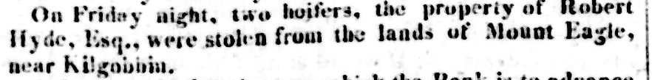
This lead me to: Kilgobbin , Parish Kilgobbin, Barony Rathdown, County Dublin
One of the neighbouring townlands on its southern border was Murphystown, and there was Mount Eagle, plain as day, smack dab in the middle of it.
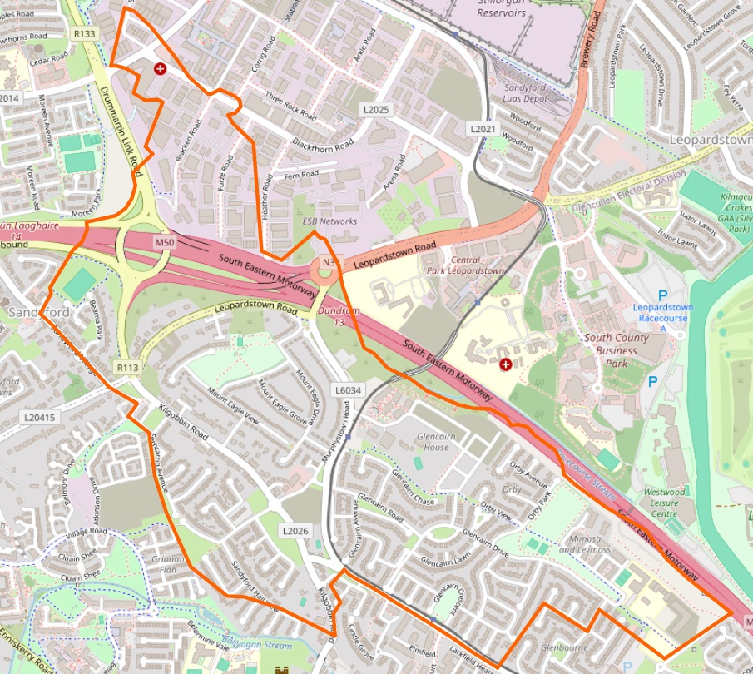
Which then lead me to the Tithe Applotment record which mentions Robert HYDE Esq.
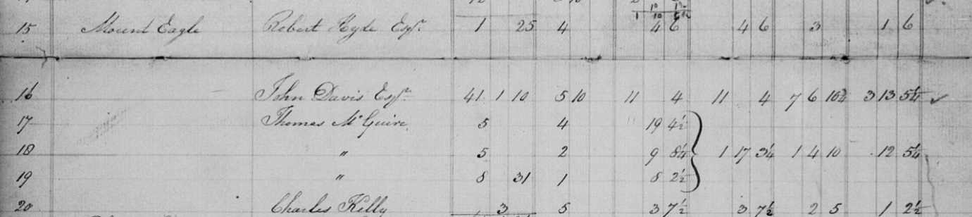

George Robert Loftus HYDE NOTE: A reasonable case can be made that George Robert Loftus HYDE is actually the Robert HYDE of Mount Eagle, and that a George HYDE was a brother.
1815 Dec 21
ROD: 697-155-478289
Image 422
BTW Robert HYDE of Mount Eagle, Co. Dublin & William WHITTHORN of City of Dublin Esq. of 1 pt & Charles MILLS of City of Dublin professor of Music of the other pt. Robert HYDE with approval of William WHITHORN & in consideration of rent confirmed to MILLS the dwelling house & Messuage & tenement on Dame Street at corner of Palace Street in City of Dublin containing in front to Dame Street 20’ [NOTE: Earlier deeds said 25’] and in the rere 16’ and from front to rere 54’ bounded on the West to Palace Street on the east by Mr. HUTCHINSONs holding on the south to Thomas DUIGNANs holding on the North to Dame Street to hold for lives of Robert HYDE his son George Robert Loftus HYDE and [lives of royalty] and 75 years for yearly rent of £245 Robert HYDE [SEAL] WITNESS: James FARLEY Bernard DOWLING NOTE: A Robert HYDE (1790- ) born at Emly ((Imleach), Parish of Emly, Barony Clanwilliam, Co. Tipperary. He may or may not be Robert Loftus HYDE. Many of this family emigrated to Australia.

This is as good a time as any to leave the realm of deeds research and plunge into the legal, and court cases involving Robert HYDE, as well as what might have contributed to the downfall of Robert HYDE. First, there was the bankruptcy of Valentine DOWNING who may have taken others down with him, SOURCE: Dublin Evening Post, August 5th, 1817. It also seems that Robert HYDE could have gone off the rails as a result of his own actions (more on that later).
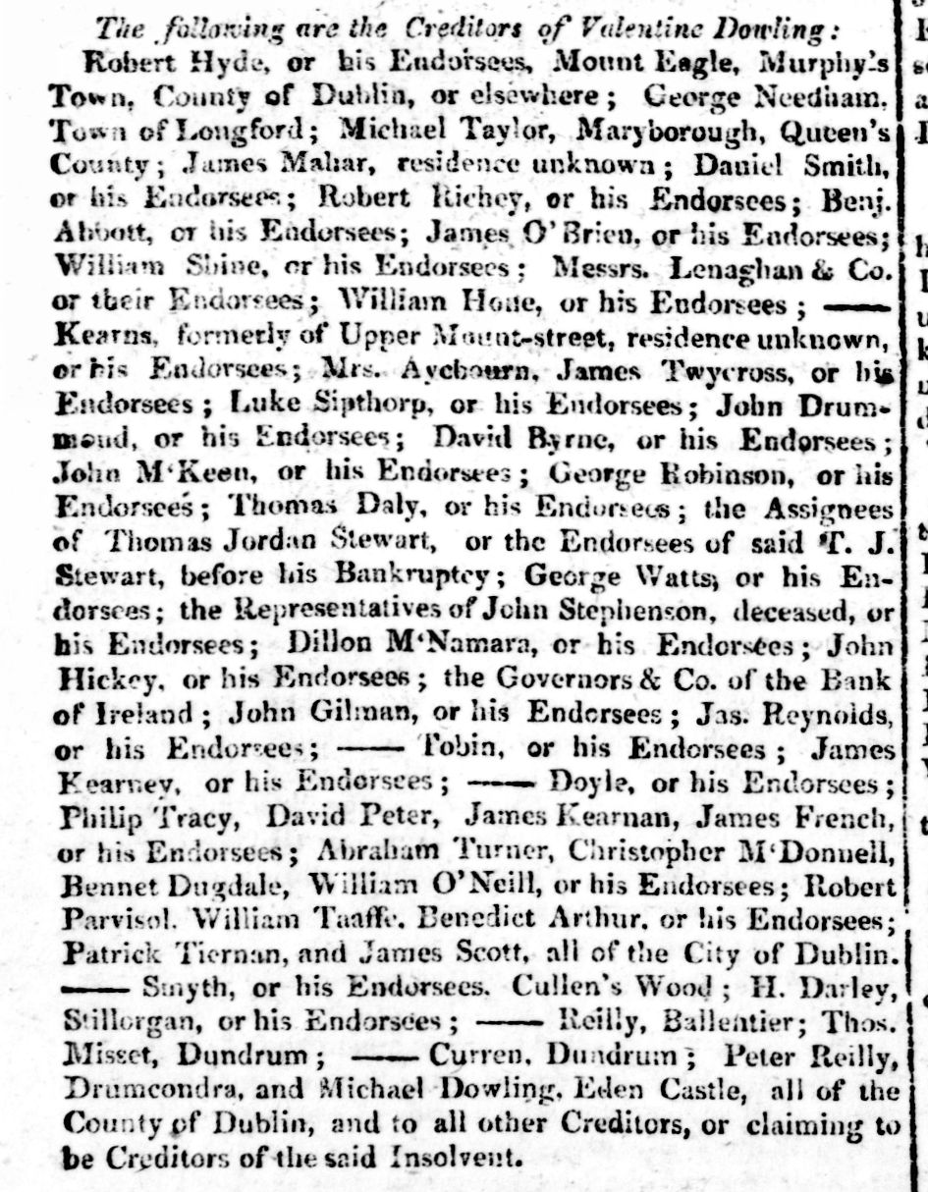

Backing up, one key question is whether Robert HYDE was a descendant of the HYDEs who settled in Youghal and elsewhere in Co. Cork in Elizabethan times. They sent multiple sons to serve in the Irish Parliament, starting with Sir Arthur HYDE in ??? followed up by his ten times grandson Douglas HYDE who was Ireland’s first serving Prime Minster. Their descendants included powerful merchants in Belfast, HYDEs who were mentioned in the Drennan-McTier Letters (1794-1901), along with Elizabeth JACKSON, the wife of Rev. William JACKSON.

The answers to such questions are still in the inter-tidal zone of my mind, somewhere between probably and possibly. For starters, there is something like a baker’s dozen of Robert HYDE’s who would be a good possible fit in just about every county in Ireland. Some middle names to distinguish them would have been helpful, but until the 1800s, they were few and far between.

The land records are a good place to start. Five years ago, I made a start with: Hyde’s Coffee Shop – corner of Palace Street and Dame Street. Time for an update, specially since Family Search launched an experiment with uploading AI versions of deeds. This means that it is now possible to tease out names of HYDEs who were neither Grantors nor Grantees: Neighbours. Relations. Witnesses. After a month of digging into them, I have found more than 100 previously unknown – to me – mentions of them. What is more, land holdings can be tracked across multiple generations and significant shifts in how townland names were spelled.

With this resource, the ownership of the Dame Street Coffee Shop leads in short order to John HYDE and Sarah HYDE, book sellers and publishers in the early 1700s. Although they lived a few generations before Robert HYDE, their ownership of premises on Dame Street, starting with premises across the street from the Coffee Shop, but ending up including the premises of the Coffee Shop rang my chimes. John HYDE’s ancestry is likewise a mystery. Did he hark back to the HYDEs of Co. Cork, or to other branches of the family who had stayed rooted in England.

Pairing A Dictionary of Members of the Dublin Book Trade 1550-1800 with the evidence in the deeds reveals a lot about John and Sarah HYDE, but also her father, also a printer: Joseph RAY.

INSERT picture of page.

Did John HYDE enter the printing business because of his wife, or did he meet her because he was already in the printing business. Here’s hoping that “real historians” can help me out.

REF & DELETED
‘Charting the East India Company’s Tea Trade‘, Did he import tea from India or America?

https://en.wikipedia.org/wiki/The_History_of_the_Rebellion published by John HYDE in Dublin
There are 11 HYDEs recorded in London Rolls.
https://www.londonroll.org/event/?company=STN&event_id=STMM16442 London Rolls HYDE Stationers. 1764 Richard son of William. No location given.
https://www.londonroll.org/event/?company=STN&event_id=STMM23510 1637 John Hyde New Freeman
By 1761, the city had already 45 printers and booksellers, rising to a height of 115 in 1796

It was both this high level of literacy, as well as a tradition of political engagement, which meant Dublins workers were inclined to form radical debate clubs in the 1790s. During the early part of the decade, Dublin newspapers were full of references to numerous obscure political clubs springing up in the city as the Union, the States, the Illuminati, the Spread, the Huguenots, the Clady, the Shoe, the Dexter, the Jason, the Shamrock, the Athenian, the Philanthropic and the Telegraphic societies32. The line between labour organization and revolutionary politics was increasingly blurred during the 1790s, with conservative newspapers relishing the application of revolutionary terminology to Dublin-s journeymen groups. In 1794, the Freemans Journal reported on a .turn out convention of sans culotte journeymen shoemakers, assembling in Rathmines, jokingly to referring how they dealt with a man who would not join the combination, they have doomed prisoner their prisoner to the guillotine, or at least a sousing in one of the levels of the Grand Canal33- Oh. The city's shoemakers seem to have had a reputation for radical politics, as later the same year, the Freemans Journal 11 again reported on how section of combining journeymen shoemakers who were surprised in high debate [...]. The master shoemakers that apprehended them having information of another department Being convened in Winetavern street, they repaired there in order to apprehend the Revolutionists. But we were supposed to be a Revolutionary Court, for them sat armed in debate; and when the master shoemakers came upon them, made a sortieWhat are they desperately wounded some of the employers? Three of them were secured at the time, and a Marat of party was taken the following morning34- Oh. In another instance, it was reported that a .Council of five hundred hundred journeymen tailors had assembled in a field near the city to listen to the "reports of their" Committee of Public Welfarepassing resolutions against certain employers who had incurred their wrath by accepting British military contracts35. In 1795, one Irish newspaper even went as far as to juxtapose the terminology of the French Terror with the names of Dublin-working-class districts: Terrorists of Pill lane, the Marats of Skinners-row, the Republican clash That nightly revels in Hoeys court and the Roberspiere Pike committee of Suffolk Street.
Considering Thomas Paes extraordinary reception in Ireland, the huge print and newspaper exposure of Rights of Man, it is reasonable to assume that Dublin artisans, like their London or Manchester counter-parts, were heavily influenced by Paine. A cheap edition of the first part of Rights of Man He was distributed in Dublin during July 1791, while Part II received an even wider dissemination due to the efforts of several radical booksellers. The United Irishmen also helped produce subdued editions, with reports of cheap (as little as 2 pennies) and in some cases copies free copies being distributed in Dublin and Cork39. One conservative Irish pamphleteer claimed that Paine had a lock on the mind of the Irish peasant and lower tradesman40- Oh. Yet Paines writings were not especially aimed at working men or wage earners. His work equally appealed to farmers, shopkeepers, small masters and professionals. His views did not challenge property rights or the emerging doctrines of laissez faire. Like Adam Smith, Paine envisioned an egalitarian society of small producers, driven by self-improvement, by .feudal, regulation or customs, where competition would prevent the accumulation of excessive wealth. While the fifth chapter of the Rights of Man part II proposals for state welfare and insurance against old age, and Agrarian Justice forwarded proposals concerning income redistribution, these were aimed at landed aristocracy, where the hereditary principle of primogeniture provided the rationale for Paines attack
Paine had not trucked with journeymen combinations and offered no framework for asserting collective rights between the exploited or dispossessed. Paine was certainly popular among radical middle-classes such as the United Irishmen, several of whom were responsible for printing editions of Paines works. Among these middle-class radicals Paines writings probably confirmed rather than inspired. their agenda, but among the new political constituency of literate tradesmen, his work had a far more innovative effect. No the wealthy was not much as adeserved aristocratic opulence: Paine divided society into the .productive versus "unproductive" classes, defined by the "those who pay taxes," and those who receive and live upon taxes42- Oh. His emphasis was on the natural interference of privilege or oligarchy on the economy. However, if this analysis of productive and unproductive groups could be used by the middle class against aristocracy, it could also be appropriated by wage earners, who saw themselves as the current producers of wealth.
In this regard, an examination of one of the other Most popular radio writers of the era is instructive, the work of the Frenchman Constantine Francois of Volney, his 1791 book The Ruins; or meditation on the Revolutions of Empires. Written in an engaging and accessible style, it was decried as one of the most prolific .corrupting books of the various "infidel" societies in London during the 1790s, while a Welsh translation was apparently in circulation by the middle of the decade43. A copy was found in Bahia, Brazil during 1797 and was linked to an insurrectionary conspiracy of mulattos and slaves, while a recent survey of the , , revolutionary Atlantic, has suggested that Volneys book may have been as important to the Age of Revolution as Paines Rights of Man44. Significantly, Volney also had a wide-wearing Irish reception. His works were included in a pamphlet that was "industriously distributed to the peasantry of the north" between 1795 and 179745. Richard Musgrave listed Volney, along with Paine and Godwin, as one of those authors, which gives wings to treason, and conveys it to the garret and the cellar46- Oh. Government reporters repeatedly passed on handbills based on Volneys writings back to the authorities. The Rebellion Papers. collection contains at least two separate editions (and numerous copies) of handbills taken from Volneys Ruins, particularly its fifteenth chapter a vision of a "New Age" which takes the form of a dialogue between the "people" and the .privileged classes47- Oh.
22In this exchange, the "People" quiz the "Privileged Class" as to why they enjoy their riches while not working:
People: What do you perform in our society?
Privileged Class: None, we are not made to work.
People: How, then, have you acquired these riches?
Privileged Class: By taking the pains to govern you.
People: What. Is this what you call? We toil and you enjoy. We produce and you dissipate. Wealth proceeds from us, and you absorb it.
23While Paine may have introduced the notion of "productive" vs. unproductive, classes, setting the aristocracy against everyone else in society, in Volney there was the seed for a more radical partition of society: .All the vices, all the political disorders, are deductible from this source; men who do nothing, and who devour the substance of others.

https://journals.openedition.org/lrf/1643?lang=es

The starting point of who was Robert HYDE began, as Churchill once said, as: a riddle wrapped in a mystery inside an enigma.

https://publishing.cdlib.org/ucpressebooks/view?docId=ft2w1004tq&chunk.id=d0e3275&toc.id=&brand=ucpress Douglas HYDE
Ironically, when I used voice recognition to transcribe the text of the ad, the words Tea Trade were rendered as E*Trade - a sign of changed times.

